SOAH DOCKET NO. 473-00-1020
PUC DOCKET NO. 22355

APPLICATION OF RELIANT § BEFORE THE STATE OFFICE
ENERGY, INC. FOR APPROVAL OF §
UNBUNDLED COST OF SERVICE §
RATE PURSUANT TO PURA § 39.201 § OF
AND PUBLIC UTILITY COMMISSION §
SUBSTANTIVE RULE 25.344 § ADMINISTRATIVE HEARINGS

TEXAS RETAILERS ASSOCIATION’S
AND TEXAS HOSPITAL ASSOCIATION’S
SUPPLEMENTAL RESPONSE TO RELIANT ENERGY
HL&P’s FIRST REQUEST FOR INFORMATION

The Texas Retailers Association and the Texas Hospital Association (“TRA/THA”) hereby supplements its response to Reliant Energy HL&P’s First Set of Requests for Information, question 1-3.
Respectfully submitted,
LAW OFFICES OF JIM BOYLE

1005 Congress Avenue, Suite 550
Austin, Texas 78701

(512) 474-1492
(512) 474-2507 FAX

By:________________________________

JAIME SLAUGHTER

State Bar No. 00794647
Attorney for TRA/THA

CERTIFICATE OF SERVICE

I certify that I have served a copy of the Texas Retailers Association and the Texas Hospital Association’s Response to Reliant Energy HL&P’s First Request for Information upon all known parties of record by fax and/or first class mail on this the 2nd day of January, 2001.

________________________

Jaime Slaughter
SOAH DOCKET NO. 473-00-1020
PUC DOCKET NO. 22355

APPLICATION OF RELIANT § BEFORE THE STATE OFFICE
ENERGY, INC. FOR APPROVAL OF §
UNBUNDLED COST OF SERVICE §
RATE PURSUANT TO PURA § 39.201 § OF
AND PUBLIC UTILITY COMMISSION §
SUBSTANTIVE RULE 25.344 § ADMINISTRATIVE HEARINGS

Question:
  - Please refer to Mr.[sic] Smith’s testimony, page 28, lines 3-8. Please provide all supporting analyses, calculations, reports, studies, or other documents relied upon in projecting that 1/3 of HL&P’s projected investment in transmission will be either cancelled or not completed before the end of 2002.

Answer:
Attached is the ERCOT “Report on Existing and Potential Electric System Constraints and Needs Within ERCOT,” October 1, 2000.

Prepared by: Ms. Lee Smith
Sponsored by: Ms. Lee Smith



REPORT ON EXISTING AND POTENTIAL ELECTRIC SYSTEM CONSTRAINTS AND NEEDS WITHIN ERCOT

October 1, 2000

Please note:
This report is best when reviewed or printed in color.

ERCOT
2705 West Lake Drive
Taylor, Texas 76574-2136
Main Office Phone (512) 248-3000
Main Office FAX (512) 248-3095
www.ercot.com
TABLE OF CONTENTS Page
DISCLAIMER 6
EXECUTIVE SUMMARY 6
INTRODUCTION 6
PURPOSE 6
REPORT DEVELOPMENT AND PROCESS 6
CONSERVATION, ENERGY EFFICIENCY AND DISTRIBUTED GENERATION PROGRAMS 6
REGULATORY AUTHORIZATION 6
TRANSMISSION LINE ROUTING 6
ERCOT ENDORSEMENT 6
REGIONAL PLANNING GROUPS 6
TRANSMISSION CONSTRAINT DEFINITION 6
OVERVIEW OF ERCOT LOAD AND GENERATION 6
Population and Climate 6
Electrical Demand (Load) 6
Location of Demand (Load) 6
Energy Requirement 6
New Generation Capacity 6
Location of Generation Capacity 6
Import/Export 6
Location of New Generation 6
Future Import/Export 6
Age of Generating Capacity 6
ERCOT ZONE MAP 6
YEAR 2000 TRANSMISSION CONSTRAINT LIMITING ELEMENTS 6
SOUTH REGION DISCUSSION 6
South Region Transmission Constraint Relief Projects 6
NORTH REGION DISCUSSION 6
North Region Transmission Constraint Relief Projects 6
HOUSTON REGION DISCUSSION 6
Houston Region Transmission Constraint Relief Projects 6
WEST REGION DISCUSSION 6
West Region Transmission Constraint Relief Projects 6
CENTRAL REGION DISCUSSION 6
Central Region Transmission Constraint Relief Projects 6
DISTRIBUTION CONSTRAINTS 6

DISCLAIMER
This document was prepared by the Electric Reliability Council of Texas (ERCOT) System Planning Technical Operations staff. It is intended to be a report of the status of transmission system in the ERCOT region and ERCOT’s recommendations to address transmission constraints. Transmission system planning is a continuous process. Conclusions reached in this report are a “snapshot in time” that can change with the addition (or elimination) of plans for new generation, transmission facilities, equipment, or loads.
ERCOT AND ITS CONTRIBUTING MEMBER COMPANIES DISCLAIM ANY WARRANTY, EXPRESS OR IMPLIED, INCLUDING ANY WARRANTY OF MERCHANTABILITY OR FITNESS FOR ANY PARTICULAR PURPOSE WHATSOEVER WITH RESPECT TO THE INFORMATION BEING PROVIDED IN THIS REPORT.
The use of this information in any manner constitutes an agreement to hold harmless and indemnify ERCOT, its Member Companies, employees and/or representatives from all claims of any damages. In no event shall ERCOT, its Member Companies, employees and/or representatives be liable for actual, indirect, special or consequential damages in connection with the use of this data. Users are advised to verify the accuracy of this information with the original source of the data.

EXECUTIVE SUMMARY
There are a number of existing limitations in the transmission system in the Electric Reliability Council of Texas (ERCOT) that have restricted service to load, have affected market participants’ ability to change electricity providers and have limited market transactions.
The current major ERCOT transmission constraints are:
- South Texas To North Texas
- To and From West Texas
- To and From South Texas and the Rio Grande Valley
- To Dallas, Denton, Collin and Tarrant Counties
- From East DC Tie Northeast Texas
- From Houston Area
ERCOT has supported and recommended the following major projects, currently under development by transmission service providers that will help mitigate these constraints. These projects are:
- Limestone-Watermill Double Circuit 345 kV Line
- Morgan Creek-Twin Buttes-Red Creek-Comanche Switch 345 kV Line
- Graham-Jacksboro 345 kV Line
- Military Highway 138 kV STATCOM Dynamic Reactive Resource
- Lon Hill-Rio Hondo and Lon Hill-Edinburgh 345 kV Lines Series Capacitor Compensation
- San Miguel-Pawnee-Coleto Creek 345 kV Line
- Monticello-Farmersville-Valley Junction-Anna Switch 345 kV Line
The following major projects have been proposed by individual transmission service providers, reviewed and are recommended by ERCOT:
- Fayette-Austrop and Holman-Lytton 345 kV Lines
- Centerville Switch-McCree Switch 345 kV Line
- Citgo SkyGen Corpus Christi Area Upgrades
- Establish White Point 345 kV Switching Station and 138 kV Upgrades
- Upgrade Cedar Bayou-King-North Belt-TH Wharton 345 kV Corridor
- Add OASIS Switch
- Kunitz-Wink 138 kV Line
ERCOT will lead five regional planning groups to determine additional actions needed to serve load and resolve transmission constraints. Major projects being considered are as follows:
- Jacksboro-West Denton 345 kV Line
- Jacksboro-Willow Creek-Parker 345 kV Line Upgrade
- West Denton-NW Carrollton 345 kV Second Circuit
- Venus-Liggett 345 kV Line
- Watermill-Cedar Hill 345 kV Second Circuit
- Paris Switch-Anna Switch 345 kV Line
- Anna Switch-Collin-NW Carrollton 345 kV Line Upgrade
- Coleto Creek-Holman 345 kV Line
- San Miguel-Laredo 345 kV Line
- Laredo-Bates-Edinburgh 345 kV Line
- Bates-Brownsville-LaPalma 345 kV Line
- Red Creek-Comanche Switch 345 kV Second Circuit
- Comanche Switch-Killeen Switch 345 kV Line
- Rio Pecos 138 kV STATCOM Dynamic Reactive Resource
- Salem-Bryan/College Station-TNP One 345 kV Line
- Zenith-Salem 345 kV Line
- Zenith-Gibbons Creek 345 kV Line
- Reliant Energy HLP-Entergy DC Tie
- Establish Williamson County 345 kV Switching Station and 138 kV Additions
- Many 138 kV and 69 kV System Additions/ Upgrades including Autotransformers
- Add Reactive Compensation

INTRODUCTION
The interconnected transmission systems are the principal media for achieving a reliable electric supply. They tie together the major electric system facilities, generation resources, and customer demand centers. These systems must be planned, designed, and constructed to operate reliably within thermal, voltage, and stability limits while achieving their major purposes. These purposes are to:
Deliver Electric Power to Areas of Customer Demand — Transmission systems provide for the integration of electric generation resources and electric system facilities to ensure the reliable delivery of electric power to meet continuously changing customer demands under a wide variety of system operating conditions.
Allow Economic and Competitive Exchange of Electric Power Among Systems — Transmission interconnections between systems, coupled with internal system transmission facilities, allow for the economic and competitive exchange of electric power among all systems and industry participants. Such transfers help to reduce the cost of electric supply to customers and provide a more liquid market.
Provide Flexibility for Changing System Conditions — Transmission capacity must be available on the interconnected transmission systems to provide the flexibility needed to handle the shift in facility loadings caused by the maintenance of generation and transmission equipment, the forced outages of such equipment, and a wide range of other system variable conditions, such as construction delays, higher than expected customer demands, and generating unit fuel shortages.
Electric power transfers have a significant effect on the reliability of the interconnected transmission systems, and must be evaluated in the context of the other functions performed by these interconnected systems. In some areas, portions of the transmission systems are being loaded to their reliability limits as the uses of the transmission systems change relative to those for which they were planned, and as various obstacles prevent new facilities from being constructed as planned. Efforts by all industry participants to minimize costs will also continue to encourage, within safety and reliability limits, maximum loadings on the existing transmission systems.
The existing and approaching competitive electricity environment is fostering an increasing demand for transmission services. With this focus on transmission and its ability to support competitive electric power transfers as opposed to traditional integrated utility operation, all users of the interconnected transmission systems should understand the electrical limitations of the transmission systems and the capability of these systems to reliably support a wider variety of energy transfers. The challenge is to plan and operate transmission systems that provide the requested electric power transfers while maintaining overall system reliability.
All electric utilities, electric cooperatives, transmission service providers, generation entities, purchasers, marketers, brokers, consumers and society at large benefit from having reliable interconnected bulk electric systems. To ensure that these benefits continue, all industry participants must recognize the importance of planning these systems in a manner that promotes reliability.
Electric systems must be planned to withstand probable forced and maintenance outages at projected customer demand and anticipated electricity transfer levels. Extreme but less probable contingencies measure the robustness of the electric systems and should be evaluated for risks and consequences. The ability of the interconnected transmission systems to withstand probable and extreme contingencies is evaluated by simulated testing of the systems.
Traditional planning methods using known generation resources and pairing them with known load are no longer possible. There is significant uncertainty in the existing generation that will be displaced by the addition of new generation. In addition, there is significant uncertainty regarding which new generators should be modeled in the future and how their operation affects existing resources and the transmission system.
The ERCOT power system consists of those generation, transmission and distribution facilities that are controlled by individual entities and which function as part of an integrated and coordinated power supply network. Beginning June 1, 2001 the ERCOT region will be operated as a single control area under the direction of ERCOT.
The Texas legislature deregulated the electric wholesale power market in 1995 and mandated the deregulation of the electric retail power market in most of ERCOT by 2002. Significant load growth along with these changes are dramatically affecting management of the transmission service in the ERCOT region.
This report contains information that describes current known ERCOT system constraints. It depicts major transmission projects under study to relieve these constraints and includes existing transmission projects recommended by ERCOT that address some of those constraints.
Transmission system planning is a continuous process. Conclusions reached in this report are a “snapshot in time” that can change with the addition (or elimination) of plans for new generation, transmission facilities, equipment, or loads.
This report was prepared by ERCOT System Planning, Technical Operations, with the cooperation and assistance of transmission service providers, distribution operation companies, load serving entities and generation entities. The new transmission projects discussed in the report are intended to ensure conformance to ERCOT Planning Criteria and North American Electric Reliability Council (NERC) system reliability standards. Such projects will be recommended if they provide adequate service to load, interconnect new generation and provide capacity for energy transactions.

PURPOSE
This report serves several purposes. The first purpose of this report is to document the process of major changes and additions to the ERCOT transmission grid. This helps to ensure continuity in the development of the transmission grid, consistency in the evaluation of grid adequacy, and helps document the need for new facilities. This report also helps identify the benefits of each project planned, as well as the consequences of project delays.
The second purpose of this document is to communicate the nature of transmission constraints and the projects being considered by ERCOT to relieve those constraints, to generation entities, load serving entities, other market groups, the public and the Public Utility Commission of Texas (PUCT). It may be useful in the preparation of regulatory and other reports that require transmission grid planning information.
The third purpose of this report is to fulfill the requirements of the Public Utility Regulatory Act (PURA), as amended by Senate Bill 7 in 1999. PURA section 39.155(b) states:
The ERCOT independent system operator shall submit an annual report to the commission identifying existing and potential transmission and distribution constraints and system needs within ERCOT, alternatives for meeting system needs, and recommendations for meeting system needs.
Finally, this report is designed to serve as a starting point for developing proposed projects for approval via the ERCOT Transmission Planning Process.

REPORT DEVELOPMENT AND PROCESS
Simulation of the transmission grid is necessary to develop this report. Such simulation requires several types of forecasted information that is supplied by various entities. Diversified station load forecasts are derived from the load serving entity system load forecasts and undiversified station load forecasts. The load serving entity distribution planning requirements, including new substations as well as the load forecasts, are communicated to ERCOT through the Annual Planned Service Request (APSR) process. Large portions of the future power supply resources projected by load entities for future years are unspecified; that is, no long term commitments have been made or are not discernible with any accuracy. This combined with the short lead time to build new generation shortens the transmission planning horizon for new resources to less than three years. Forecasts of generating unit commitment schedules and output levels are formulated with guidance from each load serving entity.
A major assumption used in the development of this report is the level of reactive compensation (voltage control) planned on the system. Future assessments and plans will be based upon achieving and maintaining the reactive capability for each load season. With the wheeling of power through the transmission grid, the siting of power supply resources remote from the major load centers and a reduction in the use of older gas-fired generation during off-peak conditions, reactive compensation has become a very important component of system reliability and ERCOT system security.
The performance criteria used in evaluating system security includes NERC Planning Standards and the ERCOT Planning Criteria. Projects included in this report have been and are continuing to be studied for their ability to satisfy the requirements of these standards.
The planning process begins with computer modeling studies of the generation and transmission facilities, and substation loads under normal conditions in the ERCOT system. Contingency conditions that might be expected to occur in operation of the transmission grid are also modeled. To maintain adequate service and minimize interruptions of service during facility outages, model simulations are used to identify adverse results and examine the effectiveness of various alternatives in alleviating those adverse results.
The effectiveness of each grid configuration and facility change must be evaluated under a variety of possible operating environments because loads and operating conditions cannot be predicted with certainty. As a result, repeated simulations under different conditions are often required. In addition, alternatives considered for future installation may affect other alternatives so that several different combinations must be evaluated, thereby multiplying the number of simulations required.
Once feasible alternatives have been identified, the process is continued with a comparison of those alternatives. To determine the most favorable alternative, the short-range and long-range benefits of each alternative must be considered. Consideration is also given to operating flexibility and compatibility with future plans.

CONSERVATION, ENERGY EFFICIENCY AND DISTRIBUTED GENERATION PROGRAMS
Additional conservation, energy efficiency and distributed generation programs may help mitigate transmission constraints and need for additional transmission. However, in a deregulated retail market, it will be much more difficult to quantify such factors. To the extent this data can be quantified and locations are identified, they will be included in future studies.

REGULATORY AUTHORIZATION
Most new transmission line construction and some line reconstruction require the approval of the PUCT. It is the responsibility of the transmission service provider building the facility to apply for and obtain the Certificate of Convenience and Necessity (CCN) and all other required regulatory approvals. The present PUCT rules allow the PUCT up to 12 months with some provisions for expedited approval for uncontested applications and critical projects. The need to perform a routing study and for the transmission service provider to hold public meetings typically adds another 12 months to the time required to certificate and build a new transmission line. In most new transmission projects, the acquisition of right-of-way and construction can take up to 12 months after a CCN is granted by the PUCT. As a result, firm commitments should be made at least three years ahead of required in-service dates for most transmission line projects and some projects may require commitments four to five years in advance of system needs.

TRANSMISSION LINE ROUTING
ERCOT's primary responsibility and concern is the reliability of the supply of electricity in an area that covers about 85% of the state. In carrying out that responsibility, ERCOT performs hundreds of short and long range technical studies to determine where potential problem areas may be and determine appropriate solutions to those technical problems. When those studies indicate new electric transmission facilities are required, ERCOT initiates a process where the technical merit of such facilities are reviewed and before such projects are formally recommended by ERCOT.
In the case of new transmission lines, no specific routing evaluation or proposal is performed at this stage, other than generally trying to favor existing rights of way and avoid known congested or environmentally sensitive areas as much as possible. Indeed, it is impossible for ERCOT to do detailed routing evaluations given the number of potential projects to consider and thousands of potentially affected landowners.
Specific routing evaluations and proposals are the responsibility of the particular transmission service provider that develops and constructs each project. ERCOT hopes that they can address landowner concerns and reach a mutually acceptable resolution. If that cannot be done, then the specific routing issues can be raised and addressed at the PUCT in Certificate of Convenience and Necessity proceedings related to the particular project. Contested issues of compensation to affected landowners are typically addressed in condemnation proceedings if necessary.
ERCOT performs no transmission line right of way routing analysis or management. Routes shown in the drawings in this document are for example only -- actual routes are the responsibility of the transmission service providers and the PUCT certification process and may be different than shown.

ERCOT ENDORSEMENT
Initial inclusion of a proposed transmission project in this report does not constitute endorsement to begin construction, nor does it indicate a final decision on need or project requirements. ERCOT Board approval must be obtained in accordance with the following process for proposed major projects:
- ERCOT staff recommends needed major transmission facility additions based on identified constraints, evaluates proposals by transmission providers and requirements for integrating new generating facilities into the ERCOT system.
- ERCOT conducts an open process of public review and comment on proposed major facility additions.
- ERCOT staff submits all final recommended transmission facility additions to the ERCOT Board of Directors for review and concurrence.
- ERCOT staff determines the designated providers of the additions.
- ERCOT notifies the PUCT of all Board supported transmission facility additions and their designated providers.
Projects proposed by individual transmission service providers also may be submitted to ERCOT for review.

REGIONAL PLANNING GROUPS
ERCOT will lead five regional planning groups (North, South, Houston, West and Central) to determine additional actions needed to resolve transmission constraints. These groups are made up of one or more engineers and/or planners from all of the transmission service providers in each of the five regions. The goals of these regional planning groups are as follows:
- To improve communication and understanding between neighboring transmission service providers of operating procedures and remedial action schemes that react to contingency, voltage, and facility overload problems.
- To help develop coordinated remedial action schemes along with operations personnel for new problems that do occur, and problems that appear likely to occur from the transmission planning process.
- To coordinate transmission planning to ensure that the ERCOT and NERC planning standards are met and all areas of concern are addressed with the good of the region in mind. The planning groups also attempt to prevent duplicate or excessive solutions to specific regional problems.

TRANSMISSION CONSTRAINT DEFINITION
A transmission constraint is defined as a limit in the transmission system that prevents the reliable delivery of electricity from the source generation selected by the load serving entity. This impacts the ability to change electricity providers and limits market transactions. It prevents the full economic and competitive exchange of electric power among all market participants.
Transmission constraints complicate ERCOT system security management, lead to economic inefficiencies and can create captive markets. They reduce liquidity of the market and create “must run” generation, resulting in increased utilization of inefficient units and reduced utilization of efficient units. They confer great market power to the dominant supplier in a constrained area.
New transmission capacity provided by system improvements maintains reliable service to load, allows new generation to be fully integrated into the grid, provides for additional competition and promotes lower energy prices. A robust transmission network is required to support a liquid competitive electricity market. Direct costs of transmission facilities are a small fraction of the total cost of electricity, typically much less than 10% of a customer’s bill.

OVERVIEW OF ERCOT LOAD AND GENERATION

Population and Climate
The ERCOT area includes about 200,000 square miles. It is a very diverse area – topographically, climatologically, and demographically. Figure 1 shows a map of Texas with the 1999 population by county. Approximate ERCOT boundaries are shown on the map.
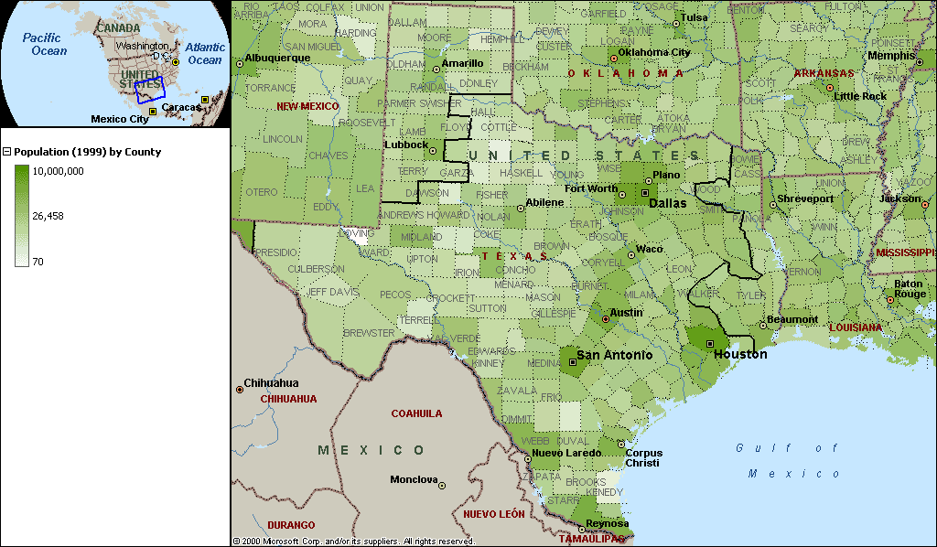
Figure 1 – 1999 Population by County
The counties range in population from Loving County in west Texas with a population of 111 to Harris County in southeast Texas with a population over 3 million. The ten most populous counties in ERCOT are Harris, Dallas, Tarrant, Bexar, Travis, Hidalgo, Collin, Denton, Fort Bend, and Cameron. The ten least populous counties in ERCOT are Loving, King, Kenedy, Borden, McMullen, Kent, Terrell, Motley, Sterling, and Glasscock; these counties are in the Panhandle, West Texas, and South Texas.
Although there are several different climatic regions in ERCOT, one constant throughout the ERCOT region is hot summers. Normal annual cooling degree-days for the state of Texas are 2,414, and normal annual heating degree-days are 1268. In some areas, the winters can be fairly cold with several inches of snow. In other areas, there is seldom a “winter.”
ERCOT represents a bulk electric system located totally within the State of Texas and serves about 85% of the electrical load in the state. Figure 2 shows the monthly peak and minimum demands for the ERCOT system for 1999.

Electrical Demand (Load)
Figure 2 – ERCOT 1999 Monthly Peak and Minimum Demand
It is clear that ERCOT is a summer-peaking system and has the lowest peaks in the spring and fall. This is due to hot weather in the summer combined with a high saturation of air conditioning. When the seasonal peaks in 1999 are compared with the annual peak, the winter peak is 71.0% of the summer peak, the spring peak is 75.4%, and the fall peak is 90.1%. The month with the lowest peak is March, and that peak is 53.2% of the summer peak. Except for the summer months, the minimum demands currently hover around 20,000 MW.
YEAR | ERCOT COINCIDENT HOURLY PEAK DEMAND MW | ANNUAL GROWTH
1994 | 43,588 | -
1995 | 46,668 | 7.07%
1996 | 47,683 | 2.17%
1997 | 50,150 | 5.17%
1998 | 53,689 | 7.06%
1999 | 54,849* | 2.16%
2000 | 57,606 | 5.03%
 | Average Six Year Compound Growth | 4.85%
*This value would have been greater if there had been no interruptible load curtailments at the time.
In the past six years, ERCOT load has grown 32.16% (14,018 MW) while very few bulk transmission additions have been made to the system to support this increased demand.
Figure 3 shows the historical coincident peak demands from 1994 through 1999 and the forecasted peak demands for 2000 through 2009 at different growth rates. The 2.7% annual growth rate is the rate derived from the Annual Planned Service Request (APSR) data submitted by the load-serving entities in 1999. The 4.7% annual growth rate is the actual annual growth rate between 1994 and 1999. The other growth rates are for illustrative purposes only.
The peaks shown for the 2.7% annual growth rate, which were derived from the APSR data, are non-coincident peaks and are not calculated on the same scale as the historical data. In order to be on the same basis as the historical data, a diversity factor could have been applied thereby lowering the peaks. Since the diversity is only about 1%, it was believed that the difference would be negligible in the graphs. As a result, the diversity factor was not applied. The peaks for the other growth rates were derived from the historical coincident peaks and therefore are calculated on the same scale as the historical data.
Figure 3 – ERCOT Peak Demands 1994-2009
It is easy to see that the peak demand has grown considerably since 1994 and is likely to continue to grow. Peak demand in 1999 was 24.4% (10,772 MW) greater than the peak demand in 1994. The growth rate slowed between 1998 and 1999 to only 2.2%. This could be a slowdown in the growth of the peak, or perhaps it is because the growth rate between 1997 and 1998 was so great (7.2%) that it makes the 1999 peak appear to be leveling off. Another factor is the interruptible load curtailment during the peak in 1999. The weather in 1998 was also extremely hot – the hottest year between 1995 and 1999. The cooling degree-days for 1998 were 121% of normal. The average growth rate between 1997-1998 and 1998-1999 is still 4.7%.
The demand in ERCOT is definitely growing, but where is the load located? Figure 4 is a map of ERCOT that shows the load by county for the summer of 2000. Note that the loads used in the following maps and discussions are non-coincident peak demands provided by the load-serving entities in the APSR.

Location of Demand (Load)
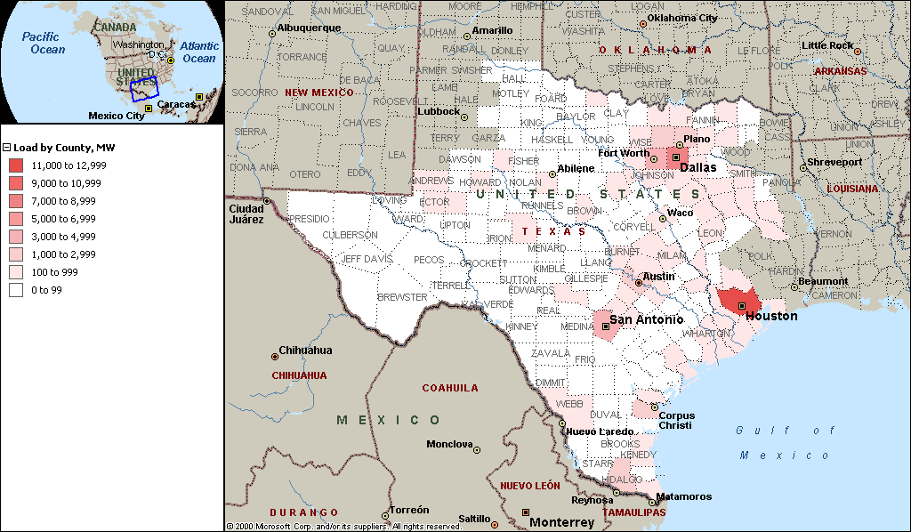
Figure 4 – Peak Demand by County for year 2000
This figure shows that the greatest peak load is in Harris County (11,113 MW). The rest of the ten counties with the greatest load are Dallas (7,738 MW), Tarrant (4,695 MW), Bexar (3,801 MW), Travis (2,509 MW), Collin (1,622 MW), Nueces (1,472 MW), Denton (1,291 MW), Hidalgo (1,029 MW), and Galveston (839 MW). These high-load areas, not surprisingly, correspond to the high-population areas (Figure 1). The ten counties with the least ERCOT load are Titus, Kenedy, Borden, Hall, Briscoe, Terrell, Crosby, Madison, Franklin, and Foard; most of these counties are in West Texas. Titus and Franklin counties are in East Texas, where the population is greater, but the ERCOT system only serves part of those counties.
Figure 5 shows counties by the load growth expected between 2000 and 2005.
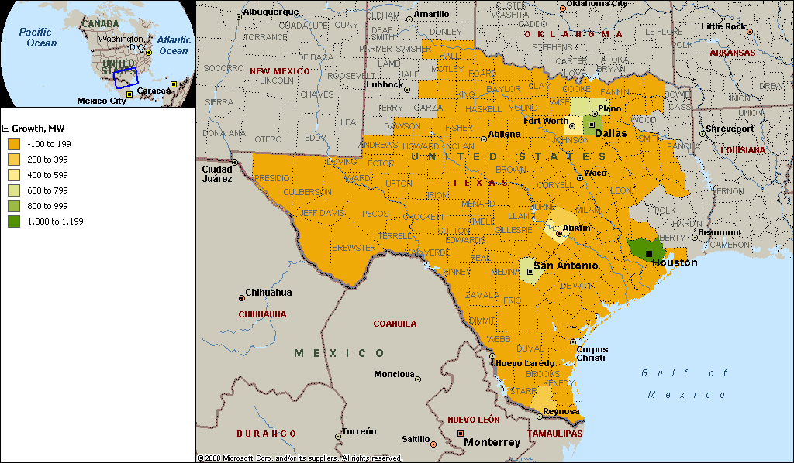
Figure 5 – Demand Growth by County Between 2000 and 2005

The counties with the largest expected growth are Harris, Dallas, Bexar, Denton, Collin, Tarrant, Travis, Hidalgo, Williamson, and Nueces. Again, these counties closely correspond with the largest population centers.

Energy Requirement

Figure 6 shows the historical and forecasted annual energy usage in ERCOT. This chart was derived from data in the December 1999 D&E Report.
Figure 6-ERCOT Annual Energy Usage

The 2.7% annual growth rate was developed from the APSR data. The actual growth rate between 1989 and 1999 was 2.6%. The 3.6% annual growth rate is the actual growth rate between 1994 and 1999. The energy usage level was fairly constant in the early 1990s but has grown steadily since 1995 except for 1999. The drop in energy usage between 1998 and 1999 is attributable to the weather. As mentioned earlier, 1998 was an extremely hot year with 121% of normal cooling degree-days.
The difference in the usage between 1998 and 1999 indicates that the usage will probably continue to grow in spite of differences in the weather. The cooling degree-days in 1999 were 10% less than in 1998, and the heating degree-days in 1999 were 17.8% less than in 1998, but the usage was only 0.4% less. This growth can be attributed to population growth, more uses for electricity, and a growing economy.

New Generation Capacity
ERCOT has received more than 110 requests for generation interconnection since 1997. These proposed plants are located all over the state. The need for capacity (load growth) in the state, revisions to the PUCT transmission rules and the newly adopted market deregulation appear to be attracting merchant plant developers to the Texas market. For the proposed plants, there is still some uncertainty because many of the proposed plants are in competition with one another and some may not be built.
IN SERVICE YEAR | NEW PROPOSED GENERATION CAPACITY
2000 | Greater than 6,500 MW
2001 | Greater than 9,500 MW
2002 | Greater than 17,500 MW
2003 | Greater than 13,000 MW
2004 | Greater than 2,000 MW
2005 | Greater than 1,500 MW
Proposed generation may help relieve or might exacerbate the current transmission constraints in ERCOT but the new plants cannot be fully accommodated by the existing transmission system. New generation projects, as well as load growth patterns, direct the need and placement of new transmission additions. The uncertainty of proposed plants and the generation they will displace impose some imprecision in transmission planning at any given time, and studies more than two years in the future begin to lose their certainty. Therefore, any new transmission additions should provide for more capacity than current identified contingencies.
It should be noted that the addition of any large generating plant could result in significant impacts to the transmission system.
The following chart, Figure 7, shows the total generation capacity in ERCOT. The data was derived from the ERCOT System Planning database, which includes all units, known unit retirements, existing and publicly proposed units in ERCOT. The proposed plants may not be built and, if built, their in-service dates are subject to change. The database includes the capacity and in-service date for most of the units and retirement dates for some units. Units that are totally dedicated to serving the needs of their own companies (i.e. “self serve loads”) are not included in Figure 7.
Figure 7 – ERCOT Total Generation Capacity
With All Existing and Proposed Plants

The planned generation additions included in Figure 7 can be found in the Generation Projects Under Development in ERCOT (updated as of 8/18/2000) on the ERCOT website. The chart also reflects units for which retirement dates were available. The latest year for which new generation is projected is 2005.

Location of Generation Capacity

Figure 8 shows a map of ERCOT with the location of the existing generation capacity by county.

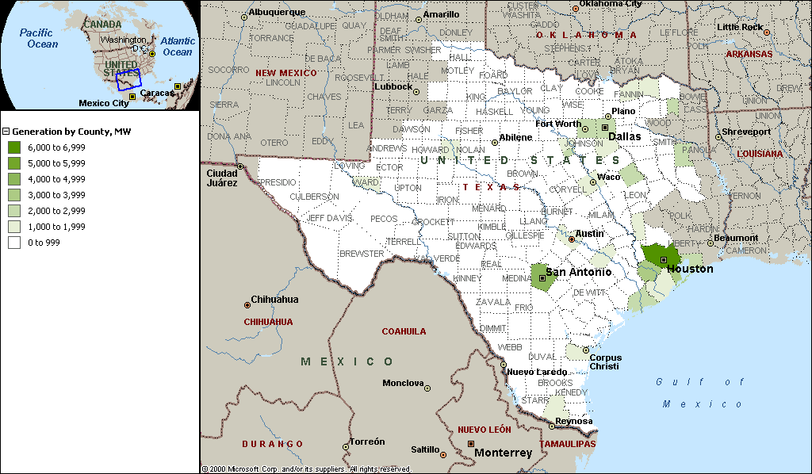
Figure 8 – Generation Capacity by County for the Year 2000

The counties with the greatest amount of capacity are Harris (6,134 MW), Bexar (4,294 MW), Fort Bend (3,783 MW), Galveston (3,129 MW), Dallas (2,978 MW), Freestone (2,682 MW), Matagorda (2,500 MW), Titus (2,480 MW), Somervell (2,300 MW), and Rusk (2,267 MW).

Import/Export

Figure 4 depicted the peak load by county, while Figure 8 depicted the generation by county. To consolidate this information, Figure 9 below is a map of the ERCOT system showing generation import/export by county for the year 2000. If a county has more generation than peak load, then it will “export” generation to other counties (blue on the map). If a county has more peak load than generation, then it must “import” generation (red on the map).

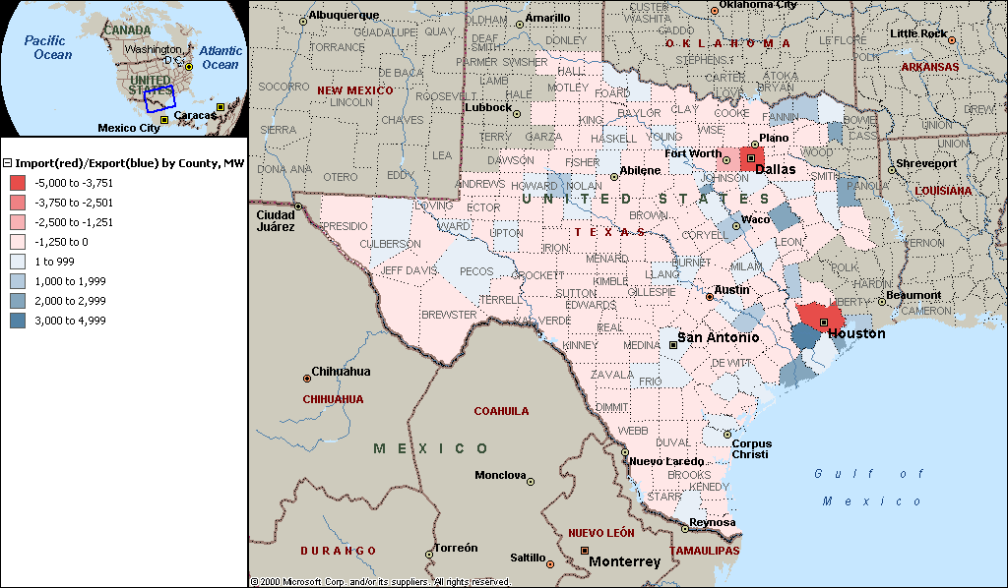
Figure 9 – Generation Import/Export by County for the Year 2000

For the year 2000 at peak load, the counties that import the most generation are Harris, Dallas, Tarrant, Collin, Denton, Travis, Bell, Williamson, Smith, and Ector. The counties that export the most generation are Fort Bend, Freestone, Titus, Matagorda, Galveston, Somervell, Rusk, Chambers, Fayette, and Grimes

Location of New Generation

Between years 2000 and 2005, about 21,000 MW of new capacity is proposed to be added to the ERCOT system. Figure 10 shows the counties where this capacity will be added. The data for this map comes from the New Generation Projects Under Development (8/18/2000) that can be found on the ERCOT website.

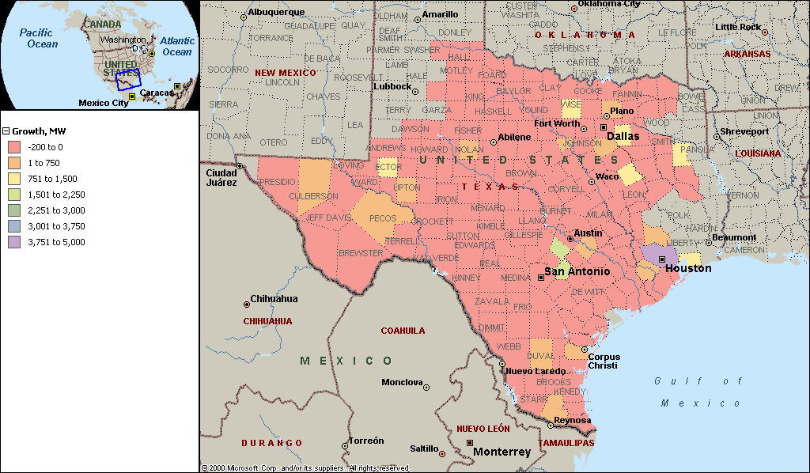
Figure 10 – New Generation Capacity Growth Between 2001 and 2005

The counties with the most planned new capacity are Harris (4,898 MW), Guadalupe (1,820 MW), Hays (1,650), Kaufman (1,500 MW), Wise (1,310 MW), Ector (1,250 MW), Freestone (1,050 MW), Rusk (850 MW), Chambers (800 MW), and Hood (750 MW). The new generation in Kaufman, Ellis, Wise, Hood, and Freestone counties will likely help provide for the needs of the Dallas-Fort Worth (DFW) area. There is also new generation in Collin County that will help to serve the DFW area.

Future Import/Export

The following map (Figure 11) shows the import and export of generation by county for the year 2002. This map was created under the assumption that all the proposed new generation is built. If a county has more generation than peak load, then it will “export” generation to other counties (blue on the map). If a county has more peak load than generation, then it must “import” generation (red on the map). Under this assumption, the counties that will import the most generation are Dallas, Tarrant, Harris, Collin, Denton, Travis, Williamson, Bell, Smith, and Angelina. The counties that will have the most generation to export are Fort Bend, Freestone, Rusk, Chambers, Titus, Matagorda, Somervell, Galveston, Hood, and Fayette.

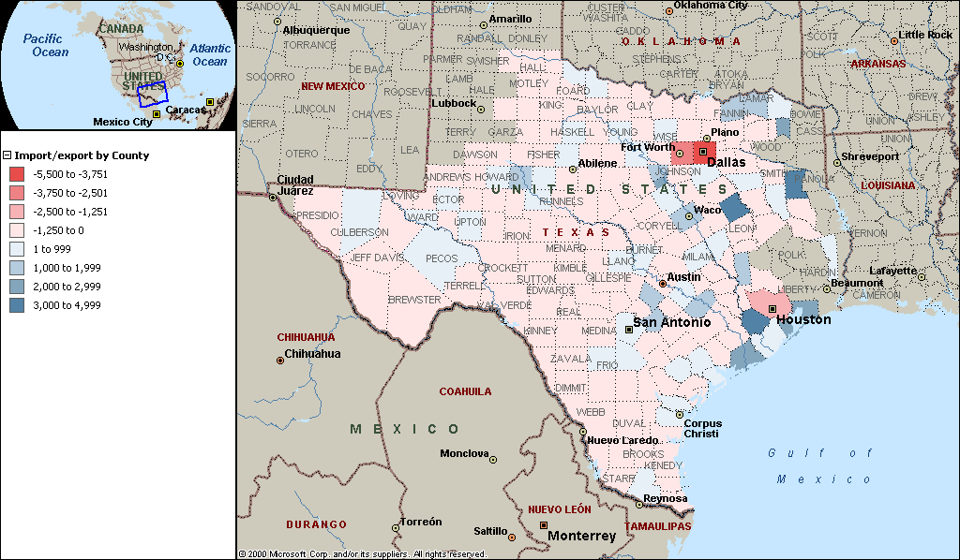
Figure 11 – Generation Import/Export by County for the Year 2002

Some changes in the counties are apparent by comparing Figures 9 and 11. Probably the most obvious change is that Harris County is importing less generation. This is supported in Figure 10, which shows that Harris County has the most new generation. Johnson, Freestone, and Chambers counties have more generation to export. Four counties (Ector, Wise, Hays, and Guadalupe) switch from importing generation to exporting generation. Each county has some degree of change, but these are the ones most apparent.
The following table compares the generation capacity import/export by county for 2000 and 2002. Most of the counties remained in the same category relative to importing or exporting but may have changed in the relative ranking.
COUNTIES BY GENERATION CAPACITY IMPORT/EXPORT
IMPORT (2000) | IMPORT (2002) | EXPORT (2000) | EXPORT (2002)
Harris | Dallas | Fort Bend | Fort Bend
Dallas | Tarrant | Freestone | Freestone
Tarrant | Harris | Titus | Rusk
Collin | Denton | Matagorda | Chambers
Denton | Collin | Galveston | Titus
Travis | Travis | Somervell | Matagorda
Bell | Williamson | Rusk | Somervell
Williamson | Bell | Chambers | Galveston
Smith | Smith | Fayette | Hood
Ector | Angelina | Grimes | Fayette
Figure 12 – Counties Ranked by Order of
Generation Capacity Import/Export

Because of the new generation capacity in Harris County, it moved from first to third in the import counties. This caused Dallas and Tarrant counties to move into the first and second positions in the 2002 import counties. Collin and Denton counties remained high on the import list. The top ten counties that have generation to export remained the same except for the new generation in Hood County that put it in the top ten in 2002 and caused Grimes County to drop out of the list. Most of the counties were in relatively similar positions in 2000 and 2002.

In this discussion, counties with the greatest population, peak load, peak load growth, generation capacity, and generation capacity growth have been ranked by magnitude. The following table (Figure 13) summarizes this information.

ERCOT TOP TEN COUNTIES BY -
POPULATION (1999) | PEAK LOAD (2000) | PEAK LOAD GROWTH (2000-2005) | GENERATION CAPACITY (2000) | GENERATION CAPACITY GROWTH (2000-2005)
Harris | Harris | Harris | Harris | Harris
Dallas | Dallas | Dallas | Bexar | Guadalupe
Tarrant | Tarrant | Bexar | Fort Bend | Hays
Bexar | Bexar | Denton | Galveston | Kaufman
Travis | Travis | Collin | Dallas | Wise
Hidalgo | Collin | Tarrant | Freestone | Ector
Collin | Nueces | Travis | Matagorda | Freestone
Denton | Denton | Hidalgo | Titus | Rusk
Fort Bend | Hidalgo | Williamson | Somervell | Chambers
Cameron | Galveston | Nueces | Rusk | Hood
Figure 13 – Top Ten Counties Ranked in Order

Although Harris County has both the highest load and capacity, its capacity is considerably less than the load. Several counties (Fort Bend, Galveston, Chambers) near Harris County have capacity available for the Harris county load. In addition, much of the generation from Matagorda County is used in the Houston area. The transmission system is essential for moving the generation from surrounding counties to Harris County.
It is significant that the county that has the second largest load and load growth ranks only fifth in capacity. The counties in the Dallas-Fort Worth area (Dallas, Tarrant, Collin, Denton) in year 2000 have a combined load of 15,346 MW but a combined capacity of only 5,865 MW. Hood, Ellis, Grayson, and Somervell counties add another 4,536 MW of capacity. Dallas, Tarrant, Collin, and Denton counties all are in the top ten for load and load growth, but only Dallas County appears in the top ten for capacity. Collin county ranks sixth in load and fifth in load growth. Denton County, which ranks eighth in load, ranks fourth in load growth. Tarrant County ranks sixth in load growth but is already at third in existing load. Since these counties already have high load and rank very high in load growth between 2000 and 2005, the differential between load and capacity will become even greater. None of the DFW counties appears in the top ten for capacity growth. There will be new capacity in Kaufman, Ellis, Wise, Hood, and Freestone counties to help serve the DFW area. Since there is no capacity growth planned in the counties in the immediate DFW area, the transmission system will be critically important for delivering power to the Dallas-Fort Worth area.
Hidalgo County ranks ninth in load and eighth in load growth, and although it is not in the top ten in capacity, it has slightly more capacity than load in 2000. Hidalgo County is not in the top ten counties in capacity growth. Additional capacity of 514 MW is planned for Hidalgo County between 2001 and 2005. The increase in load will be more than offset by this increase in capacity, and Hidalgo County should have generation to export in 2005.
Of the ten counties with the highest loads, four have generation sufficient to serve their load and to export. Those counties are Bexar, Nueces, Hidalgo, and Galveston. Of the ten counties with the greatest capacity, two (Harris and Dallas) must import generation in order to serve the load.

Age of Generating Capacity
One aspect that should be considered in determining available capacity is the age of existing units and whether there will be enough new capacity to compensate for any retirement of older units. Units for which retirement dates were available are reflected in Figure 7; however, few units in the System Planning database have retirement dates. To reflect the possibility of unit retirements, the ages of the units were analyzed by using the in-service dates. The ERCOT system was divided into areas and the age of the plants in those areas was investigated. The following map (Figure 14) shows those areas.

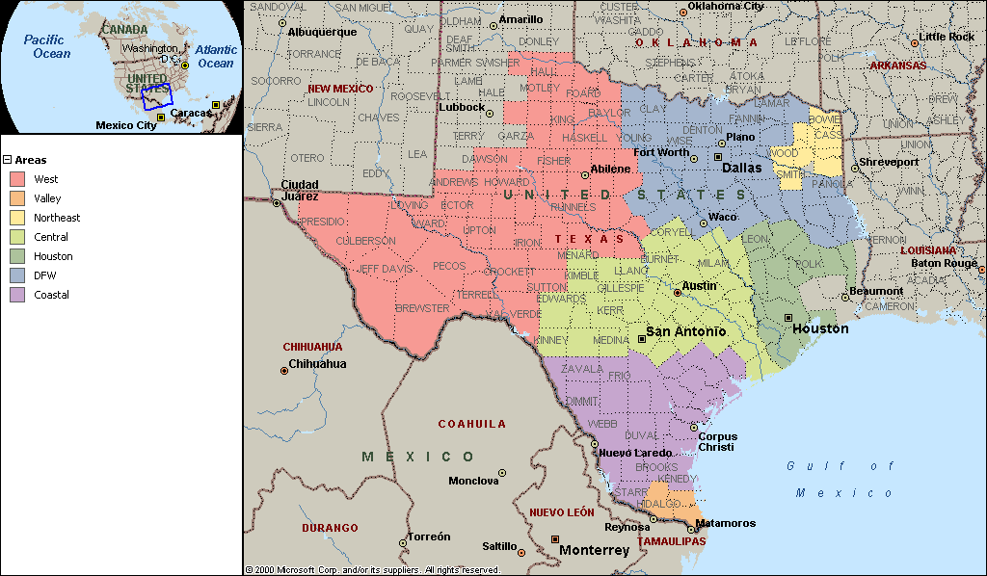
Figure 14 – Areas Used in Age-of-Plant Analysis

The following table shows capacity by area and ages of units for the areas.

GENERATION CAPACITY BY AREA AND AGE OF PLANTS IN YEAR 2000
 |  |  | AGE OF PLANTS, YEARS
AREA | > 50 | 40-49 |  | 30-39 | 20-29 |  | < 20
 | MW | MW |  | MW | MW |  | MW
WEST | 61 | 620 |  | 831 | 1,027 |  | 1,650
VALLEY | 50 | 225 |  | 156 | 101 |  | 1,067
DFW | 340 | 2,275 |  | 4,778 | 7,966 |  | 6,163
COASTAL | 36 | 477 |  | 968 | 2,076 |  | 1,154
CENTRAL | 206 | 643 |  | 1,767 | 4,716 |  | 4,952
HOUSTON | 0 | 1,559 |  | 3,581 | 6,018 |  | 3,466
NORTHEAST | 0 | 0 |  | 0 | 1,880 |  | 0
TOTAL | 693 | 5,799 |  | 12,081 | 23,784 |  | 18,452
Figure 15 – Generation Capacity by Area and Age of Plants

Most of the units greater than 50 years old are in the DFW area, followed by the central area of ERCOT. Most of the units in the other older age categories are also in the DFW area. Since older units usually require more maintenance and are generally considered less reliable than newer units, other capacity may be needed to replace these older units.

The following chart shows the total generation capacity (including available retirements and proposed generation projects) and plots of the capacity without the older units. Data is not available beyond 2005.
Figure 16 – ERCOT Generation Capacity

The following graphs combine Figure 16 and the projected load at various growth rates. Figure 17 reflects the 2.7% annual growth rate from the Annual Planned Service Requests (APSR) data, and Figure 18 reflects the 4.7% annual growth rate.
Figure 17 – ERCOT Capacity and Demand (2.7% Annual Growth Rate)
Figure 18 – ERCOT Capacity and Demand (4.7% Annual Growth Rate)
This overview has presented the historical and forecasted load, energy, and generation in ERCOT. The annual growth rates for peak demand range from 2.7% (APSR data) to 4.7 % (actual annual growth between 1994 and 1999). The annual growth rates for energy range from 2.7% (APSR data) to 3.6% (actual annual growth rate between 1994 and 1999). The capacity includes known new generation interconnections and known unit retirements, and examines potential retirements based on the in-service dates for the units.
The largest load centers do not have corresponding capacity in the immediate area. Both the Dallas-Fort Worth and the Houston areas are highly dependent on the transmission system to provide power from surrounding areas in order to serve their loads. As load continues to grow transmission additions and upgrades will be necessary to continue to reliably serve load.

ERCOT ZONE MAP
Energy transactions are expressed as coming from a zone to another zone. Zones used in ERCOT are defined below:

ZONE COMPANY
AEN Austin Energy (City of Austin)
BEC Brazos Electric Coop
BRYN Bryan Texas Utilities (City of Bryan)
CBEN North & Middle Central Power & Light
CPS City Public Service San Antonio
DC-E DC Tie East
Figure 19 – ERCOT Zone Map
DC-N DC Tie North
DGG Cities of Denton, Garland & Greenville
HLPT Reliant Energy (HLP)
LCRA Lower Colorado River Authority
STEC South Texas Electric Coop, Medina Electric Coop, San Miguel Plant
TMPA Texas Municipal Power Agency (Gibbons Creek Plant)
TNMP Texas New Mexico Power Co (Texas City)
TU TXU Electric
TU-E East Texas TXU Electric, SESCO, Rayburn Country, TxLa
TU-W West Texas TXU Electric
VALC South Central Power & Light
VALP City of Brownsville
WTU West Texas Utilities, Big Country Electric Coop

YEAR 2000 TRANSMISSION CONSTRAINT LIMITING ELEMENTS
A limiting element is a transmission line or other facility that is loaded beyond its capability when another element experiences an outage (contingency). ERCOT calculated thermal transfer limits between zones for the Winter, 1999/2000 through Fall, 2000 using On-Peak and Off-Peak seasonal power flow base cases. Based upon this analysis a list of top ten limiting elements was developed for each calculation. These were sorted to determine the relative frequency that each transmission element might limit power flow transactions to determine which limitations are possibly the most constraining elements. These limiting elements could also be involved with one or more constraints between zones. The following is a map showing the regions of ERCOT and a table showing limiting elements in priority order from highest to lowest:
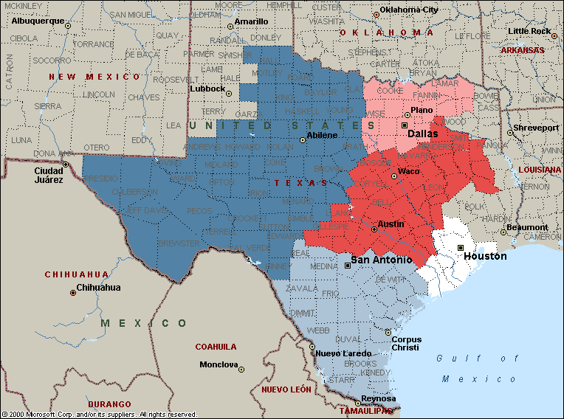
Figure 20 - ERCOT Regions
WEST REGION
NORTH REGION
SOUTH REGION
CENTRAL REGION
HOUSTON REGION

FACILITY TYPE | LIMITING ELEMENT TERMINATION POINTS & kV |  |  |  | CKT | LOCATED IN ERCOT REGION | #
Line | FISHER ROAD SS | 345 | OKLAUNION | 345 | 1 | West | 1018
Line | BIG BROWN SES | 345 | JEWETT NORTH | 345 | 1 | Central | 860
Line | SOUTH TEXAS PROJECT | 345 | LON HILL | 345 | 1 | South | 748
Line | LEON EBAA | 138 | PUTNAM TAP | 138 | 1 | West | 746
Line | GRAHAM SES | 138 | MURRAY BEC POD | 138 | 1 | West | 700
Line | SKYLINE | 345 | MARION | 345 | 1 | Central | 684
Line | LOPENO | 138 | FALCON | 138 | 1 | South | 664
Line | BIG BROWN SES | 345 | JEWETT SOUTH | 345 | 1 | Central | 551
Line | MILANO BEC POD | 138 | ROBERTSON | 138 | 1 | Central | 537
Line | MCNEIL | 138 | MCNEIL | 138 | 1 | Central | 528
Line | BEN DAVIS | 138 | OLINGER | 138 | 1 | North | 522
Line | DECORDOVA | 138 | HOOD | 138 | 1 | North | 516
Line | TRINIDAD | 345 | BIG BROWN SES | 345 | 1 | Central | 476
Line | JEWETT SOUTH | 345 | LAKE CREEK SES | 345 | 1 | Central | 475
Line | ROBERTSON | 138 | MILANO BEC POD | 138 | 1 | Central | 437
Line | WATSON CHAPEL | 138 | JEWETT | 138 | 1 | Central | 428
Line | BOONVILLE | 69 | BRIARCREST | 69 | 1 | Central | 424
Line | JEWETT | 138 | WATSON CHAPEL | 138 | 1 | Central | 416
Line | STEPHENVILLE | 138 | STEPHENVILLE TAP | 138 | 1 | West | 414
Line | ROBERTSON | 138 | HEARNE | 138 | 1 | Central | 398
Line | HILLTOP | 138 | NWEATHERFORD | 138 | 1 | North | 385
Transformer | NORTH DENTON | 138 | NORTH DENTON | 69 | 1 | North | 374
Line | BLESSING | 138 | LOLITA | 138 | 1 | South | 359
Transformer | JEWETT NORTH | 345 | JEWETT | 138 | 1 | Central | 338
Transformer | DOW-VELASCO | 345 | DOW-VELASCO | 138 | A1 | Houston | 299
Line | KILLEEN FORT HOOD TAP | 138 | KILLEEN CLEAR CREEK | 138 | 1 | Central | 298
Transformer | DENTON | 138 | NORTH DENTON | 69 | 1 | North | 296
Line | SAN MARCOS | 138 | CANYON | 138 | 1 | Central | 293
Line | GRAHAM SES | 345 | MORGAN CREEK SES | 345 | 1 | West | 285
Line | WEST COLUMBIA MAIN | 138 | SWEENY COGEN LP | 138 | 2 | Houston | 260
Transformer | GIBBONS CREEK | 138 | GIBBONS CREEK | 345 | 1 | Central | 249
Line | ROBERTSON | 138 | WATSON CHAPEL | 138 | 1 | Central | 237
Line | HILL COUNTRY | 345 | MARION | 345 | 1 | Central | 215
Line | RACHAL | 138 | NORTH EDINBURG | 138 | 1 | South | 214
Line | CORINTH | 138 | SPENCER INTERCHANGE | 138 | 1 | North | 194
Line | OKLAUNION | 345 | FISHER ROAD SS | 345 | 1 | North | 189
Line | CADDO SW STA | 138 | HEIGHTS SUB | 138 | 2 | Houston | 187
Line | MCCOLL ROAD | 138 | NORTH EDINBURG | 138 | 1 | South | 182
Line | SANDOW | 138 | ROGERS | 138 | 1 | Central | 176
Line | ELGIN SS | 138 | ELGIN | 138 | 1 | Central | 175
Line | HOLLIDAY | 69 | KMA TAP | 69 | 1 | West | 168
Line | VENUS SOUTH | 345 | TRADINGHOUSE SES | 345 | 1 | Central | 163
Line | ELECTRA | 69 | WAGGONER REFINERY | 69 | 1 | West | 152
Transformer | GREENVILLE STEAM | 138 | STEAM | 69 | 1 | North | 150
Line | FRATT | 138 | KIRBY | 138 | 1 | South | 141
Line | CRANE | 138 | WTU CRANE | 138 | 1 | West | 141
Line | LAKE CREEK SES | 138 | TEMPLE SS | 138 | 1 | Central | 136
Line | PETERS | 138 | BELLVILLE | 138 | 1 | Central | 134
Line | TEMPLE SS | 138 | ROGERS | 138 | 1 | Central | 131
Line | ABILENE SOUTH | 138 | PUTNAM TAP | 138 | 1 | West | 129
Line | AIRCO | 138 | UNION CARBIDE-SEADRIFT | 138 | 1 | South | 123
Line | ROYSE | 138 | GREENVILLE STEAM | 138 | 1 | North | 119
Line | WEST COLUMBIA | 138 | WEST COLUMBIA MAIN | 138 | 2 | Houston | 116
Line | MORGAN CREEK SES | 345 | ABILENE MULBERRY CREEK | 345 | 1 | West | 113
Line | COPPERAS COVE | 138 | COPPERAS COVE | 138 | 1 | Central | 110
Line | LEON CREEK | 138 | PLEASANTON | 138 | 1 | South | 110
Line | ZORN | 345 | LYTTON SPRINGS | 345 | 1 | Central | 104
Line | HOLMAN | 345 | LYTTON SPRINGS | 345 | 1 | Central | 100
Line | BEN DAVIS | 138 | OLINGER | 138 | 2 | North | 99
Line | FRATT | 138 | PARKWAY | 138 | 1 | South | 98
Line | AIRCO | 138 | RINCON | 138 | 1 | South | 94
Line | FAYETTE POWER PLANT | 345 | HOLMAN | 345 | 1 | Central | 90
Line | AUSTROP | 345 | FAYETTE POWER PLANT | 345 | 1 | Central | 89
Line | HEARNE | 138 | DANSBY | 138 | 1 | Central | 87
Line | COLETO CREEK | 138 | VICTORIA PLANT | 138 | 1 | South | 82
Line | STOCKDALE ROAD | 138 | KENEDY SWITCHING | 138 | 1 | South | 72
Line | RICHARDSON EAST | 138 | APOLLO | 138 | 1 | North | 66
Line | FALLS CITY | 138 | KENEDY SWITCHING | 138 | 1 | South | 66
Line | SOUTH LANE CITY | 138 | LANE CITY | 138 | 1 | Houston | 66
Line | JEWETT NORTH | 345 | TWIN OAK SES | 345 | 1 | Central | 64
Line | BLESSING | 138 | LANE CITY | 138 | 1 | Houston | 62
Line | ELGIN | 138 | MCNEIL | 138 | 1 | Central | 61
Line | AUSTROP | 138 | DECKER POWER PLANT | 138 | 1 | Central | 59
Line | ARMSTRONG | 138 | RAYMONDVILLE | 138 | 1 | South | 58
Line | PARISH, W A PLANT | 345 | SOUTH TEXAS PROJECT | 345 | 39 | Houston | 56
Line | AUSTROP | 345 | AUSTROP | 345 | 1 | Central | 54
Line | J.K. SPRUCE | 345 | LON HILL | 345 | 1 | South | 50
Line | SAN MIGUEL SWITCHYARD | 138 | SAN MIGUEL LINE | 138 | 1 | South | 49
Line | HELOTES | 138 | CICO | 138 | 1 | Central | 48
Line | BROWNWOOD SS | 138 | GOLDTHWAITE | 138 | 1 | West | 48
Line | GIBBONS CREEK | 138 | STEEP HOLLOW | 138 | 1 | Central | 47
Line | PERMIAN BASIN SES | 138 | BARRILLA | 138 | 1 | West | 45
Line | SANDOW | 138 | ROCKDALE | 138 | 1 | Central | 43
Line | GRAHAM SES | 345 | ABILENE MULBERRY CREEK | 345 | 1 | West | 40
Line | SELDON BEC POD | 138 | JOHNSVILLE BEC POD | 138 | 1 | West | 40
Line | SOUTH TEXAS PROJECT | 345 | SKYLINE | 345 | 1 | South | 39
Line | BOWIE | 138 | HARDY SWITCH | 138 | 1 | North | 39
Line | WEST COLUMBIA | 138 | WEST COLUMBIA MAIN | 138 | 1 | Houston | 39
Line | VENUS NORTH | 345 | TRADINGHOUSE SES | 345 | 1 | Central | 38
Line | DECKER POWER PLANT | 138 | AUSTROP | 138 | 1 | Central | 38
Line | LAKE CREEK SES | 345 | TEMPLE SS | 345 | 1 | Central | 37
Line | ROBINSON, P H PLANT | 138 | FREEWAY PARK | 138 | 1 | Houston | 37
Line | LON HILL | 345 | NORTH EDINBURG | 345 | 1 | South | 36
Line | LON HILL | 138 | ORANGE GROVE | 138 | 1 | South | 33
Line | LON HILL | 345 | RIO HONDO | 345 | 1 | South | 32
Line | JEWETT SOUTH | 345 | LIMESTONE PLANT | 345 | 1 | Central | 31
Line | SANDOW | 345 | AUSTROP | 345 | 1 | Central | 30
Line | WATERMILL W | 345 | TRINIDAD | 345 | 1 | Central | 30
Line | FRONTERA | 138 | FRONTERA | 138 | 1 | South | 29
Line | FAYETTE POWER PLANT | 345 | AUSTROP | 345 | 1 | Central | 25
Line | MCCOLL ROAD | 138 | NORTH MCALLEN | 138 | 1 | South | 25
Line | AUSTROP | 345 | FAYETTE POWER PLANT | 345 | 1 | Central | 24
Line | MURRAY BEC POD | 138 | PAINT CREEK | 138 | 1 | West | 24
Line | JEWETT NORTH | 345 | TOMBALL | 345 | 1 | Central | 23
Line | RADIUM WTU METER | 138 | PAINT CREEK | 138 | 1 | West | 23
Transformer | SAN ANGELO RED CREEK | 138 | SAN ANGELO RED CREEK | 345 | 1 | West | 23
Line | SIGMOR | 138 | SAN MIGUEL SWITCHYARD | 138 | 1 | West | 22
Line | OBRIEN | 345 | GIBBONS CREEK | 345 | 1 | Central | 21
Line | MARION | 345 | SAN MIGUEL | 345 | 2 | South | 21
Line | AMOCO SUB | 138 | APACHE SW STA | 138 | 1 | Houston | 20
Line | BELLVILLE | 138 | BELLVILLE WEST | 138 | 1 | Central | 19
Line | VENUS NORTH | 345 | BIG BROWN SES | 345 | 1 | Central | 18
Line | PETERS | 138 | PETERS | 138 | 1 | Central | 18
Line | TENASKA FRONTIER | 345 | GIBBONS CREEK | 345 | 1 | Houston | 13
Line | GIBBONS CREEK | 345 | OBRIEN | 345 | 1 | Central | 12
Line | KINGSBERY | 138 | WHELESS LANE | 138 | 1 | Central | 11
Line | GILLESPIE | 138 | FORT MASON | 138 | 1 | Central | 10
Transformer | AUSTROP | 345 | AUSTROP | 138 | 2 | Central | 8
Line | JEWETT NORTH | 345 | LIMESTONE PLANT | 345 | 1 | Central | 8
Line | MOSES BUS TIE | 345 | ROYSE SS | 345 | 1 | North | 8
Line | LYTLE | 138 | SOMERSET | 138 | 1 | Central | 8
Transformer | MARION | 345 | MARION | 138 | 1 | Central | 7
Line | MARION | 345 | SAN MIGUEL | 345 | 1 | Central | 7
Line | JEWETT SOUTH | 345 | WHARTON, T H PLANT | 345 | 1 | Central | 7
Line | PALO PINTO BEC POD | 138 | LONG | 138 | 1 | West | 7
Line | MCNEIL | 138 | MCNEIL | 138 | 1 | Central | 7
Line | SANDOW | 345 | AUSTROP | 345 | 2 | Central | 6
Line | SOUTH TEXAS PROJECT | 345 | HILL COUNTRY | 345 | 1 | South | 6
Line | GRAHAM SES | 345 | SWEETWATER COGEN | 345 | 1 | West | 6
Line | SOUTH TEXAS PROJECT | 345 | DOW-VELASCO | 345 | 18 | Houston | 6
Line | GRAHAM D | 345 | SWEETWATER COGEN | 345 | 1 | West | 5
Line | MONTICELLO SES | 345 | ROYSE SS | 345 | 1 | North | 4
Line | AUSTROP | 345 | ZORN 2 | 345 | 1 | Central | 4
Line | WEST DENTON | 138 | AIRPORT | 138 | 1 | North | 4
Line | TRINIDAD | 345 | BIG BROWN SES | 345 | 1 | Central | 3
Line | TRI-CORNER | 345 | SEAGOVILLE SS | 345 | 1 | North | 3
Line | WATERMILL | 345 | TRI-CORNER | 345 | 1 | North | 3
Line | HICROSS | 138 | HI CROSS | 138 | 1 | Central | 3
Transformer | KENDALL | 138 | KENDALL | 345 | 1 | Central | 3
Line | LYTTON SPRINGS | 138 | PILOT KNOB | 138 | 1 | Central | 3
Line | ROBINSON, P H PLANT | 138 | SOUTHSHORE | 138 | 1 | Houston | 3
Line | EDNA | 138 | VICTORIA PLANT | 138 | 1 | South | 3
Transformer | AUSTROP | 345 | AUSTROP | 138 | 2 | Central | 2
Line | SOUTH TEXAS PROJECT | 345 | HOLMAN | 345 | 1 | Houston | 2
Line | MARION | 345 | ZORN 2 | 345 | 1 | Central | 2
Line | CICO | 138 | COMFORT | 138 | 1 | Central | 2
Line | FAYETTE POWER PLANT | 345 | LYTTON SPRINGS | 345 | 1 | Central | 1
Line | DOW-VELASCO | 345 | SOUTH TEXAS PROJECT | 345 | 27 | Houston | 1
Line | SONORA | 138 | CAUTHORN | 138 | 1 | West | 1
Line | ROBINSON, P H PLANT | 138 | GAF SUB | 138 | 1 | Houston | 1
Transformer | LA PALMA | 138 | LA PALMA | 345 | 1 | South | 1
Line | ROUND ROCK | 138 | MCNEIL | 138 | 1 | Central | 1
Line | GEORGE WEST | 138 | ORANGE GROVE | 138 | 1 | South | 1
Line | WEST DENTON | 138 | POCKRUS | 138 | 1 | North | 1
Line | HI CROSS | 138 | TURNERSVILLE | 138 | 1 | Central | 1

SOUTH REGION DISCUSSION
Significant changes have occurred in the South Texas system, including new generation additions. Up to 3,263 MW of new Independent Power Production (IPP) generation is expected to come on line in South Texas. Furthermore, this year two additional IPP’s have requested interconnection near Corpus Christi that may increase the total generation to over 6,000 MW in the South Region.
Historically, South Texas has had a shortage of generation to serve local load that has resulted in significant imports. Imports to South Texas are limited by the post-contingency thermal loading limits of the 138 kV and 69 kV circuits along the Gulf Coast. This constrains all power flowing to the Corpus Christi area and load to the south. This condition occurs when load exceeds generation in South Texas and is still likely to occur when generation is forced out or is off line for maintenance.
Exports from South Texas are limited by the post-contingency thermal loading limits of the 138 kV and 69 kV circuits in the Corpus Christi-Victoria area. This condition constrains all power flowing to load north and west of Corpus Christi and occurs during light load conditions when generation greatly exceeds load.
Proceedings of PUCT Project 20948 “Investigation of Issues Relating to Open-Access Interconnections Between ERCOT and Mexico” has resulted in recommendations to construct asynchronous ties (DC) totaling 600 MW at the following locations: Brownsville, McAllen and Laredo. These additional interconnections between ERCOT and Mexico will improve transmission reliability for the Rio Grande Valley by providing voltage support, access to emergency power, frequency stability, and “black start” capability. In addition, open access interconnections between ERCOT and Mexico provides the capability for economic transfers of energy between the countries -- thus allowing for lower energy costs and are favoring the interests of end use customers and generators in both Texas and Mexico. However, without additional transmission capability, the energy flow on these ties may exacerbate the transmission constraints to and from South Texas.
Recent studies of the Laredo area indicate a possible voltage collapse under a single contingency outage with a generator in Laredo out of service. Voltage and dynamic stability studies of the Rio Grande Valley indicate that stability problems still exist for transfers to and from the Valley. Without additional transmission, transactions from other areas of Texas to Laredo/Valley/Mexico will increase the likelihood of these events and the possible interruption of load. Also, without additional transmission, transactions from the Laredo/Valley/Mexico to other areas of Texas will be constrained due to dynamic stability limits.
Substantial changes to the power system have occurred in the lower Rio Grande Valley. There are 1,073 MW of new IPP generation in service, and 795 MW are currently under construction. All of the new generation has been located on the west side of the Valley near Edinburg and Mission. Several 138 and 69 kV transmission line improvements have been completed to interconnect the new generation to the grid. In order to increase the transfer capability to export power, series capacitors are being installed on both of the 345 kV transmission lines interconnecting the Valley. Electric load in the Valley is growing at a rate of 5% per year, in addition to a proposed new 200 MW load by Sharyland Utilities near South McAllen. Of the total Valley load of 1,500 MW, 900 MW is located in the western end of the Valley around Edinburg and McAllen.
About 200 MW to 500 MW of new load is expected to be added to the eastern end of the Valley. This additional new load will increase the peak Valley load to 1,800 to 2,000 MW.
Extreme events, such as hurricanes, have resulted in numerous transmission outages and generation plants being forced off line in the South Region. Additional 345 kV transmission facilities located in South Texas will help to maintain service to load over a very wide area during these extreme events. Transmission along with DC ties could also provide for additional assistance between the Texas and Mexico grids.
In summary, additional transmission in South Texas will be necessary to support service to load, IPP project development and possible transactions with Mexico.

South Region Transmission Constraint Relief Projects
To address the major constraints in South Texas, the following projects are recommended by ERCOT as needed transmission facility additions and were supported by the ERCOT Board in December 1998.
MILITARY HIGHWAY 138 KV STATCOM DYNAMIC REACTIVE RESOURCE
Needed to help prevent voltage collapse and stabilize voltage on the east side of the Valley.

LON HILL-RIO HONDO AND LON HILL-EDINBURGH 345 KV LINES SERIES CAPACITOR
COMPENSATION
Needed to increase transfer capability to and from the Valley, maintain dynamic and voltage stability.

SAN MIGUEL-PAWNEE-COLETO CREEK 345 KV LINE
Needed to increase transfer capability to and from Corpus Christi area and south. Line is an integral part of the
overall transmission plan for South Texas. Will help to maintain service to load over a wide area during
extreme events.
Individual transmission service providers in South Region have proposed the following projects. These projects have been reviewed and are recommended by ERCOT:
ESTABLISH WHITEPOINT 345/138 KV SWITCHING STATION AND 138 KV UPGRADES
ESTABLISH 345/138 KV STATION AT WHITEPOINT
TIE LON HILL TO RINCON AND PORTLAND TO NUECES BAY 138 KV LINES INTO
WHITEPOINT
UPGRADE DUPONT SW TO PORTLAND AND PORTLAND TO WHITEPOINT 138 KV LINES
UPGRADE DUPONT SW TO WHITEPOINT AND LON HILL TO WHITEPOINT 138 KV LINES
Needed to integrate new IPP generation on the north side of Corpus Christi.

CITGO SKYGEN CORPUS CHRISTI AREA UPGRADES
UPGRADE THE 69 KV LINE FROM HIGHWAY 9 TO WEIL LINE TO 138 KV
UPGRADE THE 69 KV LINE FROM NUECES BAY TO INDUSTRIAL TO HIGHWAY 9 LINE
TO 138 KV
UPGRADE THE CITGO NORTH OAK PARK TO CITGO EAST AND THE CITGO EAST TO
HIGHWAY 9 138 KV LINES
UPGRADE THE WEIL TRACT TO CITGO WEST AND CITGO WEST TO LON HILL 138 KV
LINES
UPGRADE THE NUECES BAY TO HEARN’S FERRY AND THE HEARN’S FERRY TO LON
HILL 138 KV LINES
RECONDUCTOR THE NUECES BAY TO SOUTHWESTERN 138 KV TRANSMISSION LINE
ADD THIRD 345/138 KV AUTOTRANSFORMER AT LON HILL
Needed to integrate new IPP generation on the South side of Corpus Christi.
ERCOT, along with transmission service providers, is working to determine appropriate future actions and the following projects are being considered:
SAN MIGUEL-LAREDO 345 KV LINE
Needed to support service to load in Laredo and possible transactions to and from Mexico. Also provides part
of another transmission path to the Valley.

LAREDO-BATES-EDINBURGH 345 KV LINE
Needed to support service to load in Laredo, service to load in the Valley and possible transactions to and from
Mexico. Also provides part of another transmission path to the Valley. Increases transfer capability to and
from the Valley. Will help to maintain service to load over a wide area during extreme events.

BATES-BROWNSVILLE-LAPALMA 345 KV LINE
Needed to support service to load, integrate IPP generation and possible transactions to and from Mexico.

DUVAL COUNTY IPP UPGRADES AND ADDITIONS
Needed to integrate IPP generation.

COLETO CREEK-HOLMAN 345 KV LINE
Possibly needed to increase transfer capability to and from Corpus Christi and south.

UPGRADE 138KV AND 69 KV SYSTEMS
Needed to maintain service to load and integrate IPP generation.

ERCOT-MEXICO DC TIES
Needed to support transactions to and from Mexico.

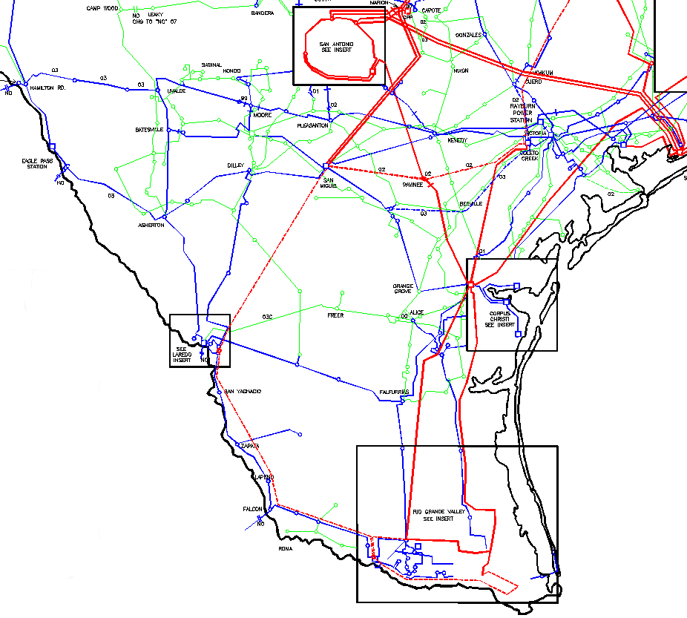
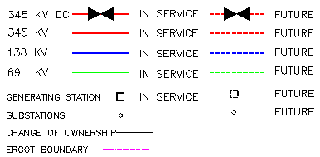
COLETO CREEK-PAWNEE 345 KV LINE
SAN MIGUEL-PAWNEE 345 KV LINE
SAN MIGUEL-LAREDO 345 KV LINE
LAREDO-BATES 345 KV LINE
BATES-EDINBURGH
BATES-BROWNSVILLE-LaPALMA 345 KV LINE
MILITARY HIGHWAY DYNAMIC REACTIVE
COLETO CREEK-HOLMAN 345 KV LINE
DUVAL COUNTY IPP
RIO GRANDE VALLEY UPGRADES
WHITEPOINT & SKYGEN UPGRADES

Figure 21 – ERCOT South Region and Transmission Projects

NORTH REGION DISCUSSION
The Dallas/Fort Worth Area (DFW) is one of ERCOT’s two largest load centers, with a total load in year 2000 of about 15,000 MW. Although DFW load is concentrated inside a four-county area, few power plants are located inside that region to serve that load. The region is served by TXU Electric and the City of Denton and City of Garland municipal utilities. DFW generation totals about 5,300 MW, with the remainder imported over the ERCOT transmission grid. A number of new merchant power plants are being planned or built in North Texas, but all are outside the transmission-constrained metro area. “Greenfield” sites for new generation development are limited and are likely to encounter public opposition.
The four-county DFW area (Collin, Dallas, Denton and Tarrant) has been designated by the Environmental Protection Agency (EPA) and Texas Natural Resources Conservation Commission (TNRCC) as a non-attainment area for ground-level ozone, which is produced in part from nitrogen oxide (NOx) emissions from fossil fuel burning. A recently-approved EPA State Implementation Plan (SIP) mandates specific actions to reduce emissions of NOx from various sources within the area by 2003, with additional reductions required by 2005.
To conform to the new SIP, DFW power plants will be required either to retrofit generation units with new NOx reduction devices, or to reduce or cease operation. Because the existing DFW transmission system was designed assuming continued operation of this in-area generation capacity, the DFW area could experience significant problems of peak period supply adequacy and voltage stability if significant amounts of the in-area generation becomes unavailable and no new in-area plants are built. ERCOT in performing transmission planning, has studied hypothetical plant shutdown scenarios and reached several conclusions.
The existing 345 kV transmission capability outside the DFW region has inadequate transfer capability to allow full replacement generation to be provided to the DFW area from remote locations. Although there are several 345 kV projects currently in planning, permitting, or construction that will help this deficiency, it appears much more transmission capacity will be needed to eliminate such problems.
Existing 345/138 kV transformers around the perimeter of the four-county area have inadequate transfer capability to import full replacement power into the area. While some contingency transformer loading will be more severe than others, the aggregated total transformer thermal capability for the area is itself inadequate, regardless of the location of the units providing the replacement power from outside the area.
The change in power flow patterns on the 138 kV load-serving system within the four-county area that will result from replacement of the existing 138 kV-connected gas-fueled plants in the DFW area by supply from other generation through existing and new 345/138 kV autotransformers, at very different locations, will present contingency overloads not previously indicated on the 138 kV system.
The loss of the dynamic reactive capability (voltage control) normally supplied by the existing gas-fueled units, along with the dramatic increase in system reactive loss which would accompany replacement of these local MW sources with those in remote locations, may greatly increase the risk of voltage collapse in the region. Even without any plant shut-downs, several parts of the DFW area are already weak in voltage stability and, with continuing high load growth, will need greater support from either more local generation, more targeted transmission facility support, significant load reduction, or advanced reactive power management technologies.
Considering economics and good utility practice, ERCOT does not believe that sufficient transmission facilities can be installed to completely remove the need for generation in the DFW area. Further, ERCOT believes that a combination of new voltage (VAR) support projects, strategic additions to the transmission system and maintaining an appropriate level of generation in the area is the only way future reliability needs for the DFW area can be met. In addition, the existing 138 kV transmission system is inadequate to handle significant increases in new generation at existing generation sites.
Large IPP generating facilities are being installed south of the DFW area, including 1,500–1,650 MW of new generation being connected to the Venus 345 kV buses. Much of this energy is delivered to the DFW area by 345 kV lines to the 345/138 kV autotransformers at Liggett, Norwood, and Cedar Hill. In 2003, even without contingency outages, the existing Venus – Liggett 345 kV circuit loading will exceed its rating. In 2002 and 2003, several DFW area 345 kV, 138 kV and generating unit contingency outages will result in the Venus – Liggett 345 kV circuit loading above its rating.
The 345 kV transmission system in the northeast Texas portion of ERCOT was originally developed to transport energy from the Valley and Monticello generation facilities to the load in the DFW area. Energy transfers in that area exceeded the original design limits of the 345 kV facilities when the 600 MW East HVDC tie was placed in service. The Monticello – Anna Switch 345 kV line transmission project is currently underway to increase the transfer levels for the Monticello – DC Tie area.
The installation of the 1,100 MW Lamar Power Project near Paris increased the transmission constraints in the North Region. Several single and double circuit contingency conditions result in thermal overloading of the 345 kV and/or the 138 kV circuits in the northeast ERCOT area. Specifically, for summer peak 2000, outage of the Valley to Paris, Moses Tap to Moses (or Moses to Allen), Moses to Sulphur Springs, and Moses to Royse 345kV lines displayed at or above capacity loading under single contingency outage conditions. Outage of the Valley to Paris 345 kV line resulted in loading beyond rated capacity of the underlying 138 kV system between Paris and Valley.
A tower outage of the Moses to Royse and Moses to Sulphur Springs 345 kV lines produced loading beyond rated capacity on the Valley to Anna and Moses to Royse 345 kV transmission lines. In addition, in this scenario, the Moses to Sulphur Bluff 138 kV line loads above its capability.
Furthermore, with the additional 1,100 MW Lamar Power Project serious generation unit stability problems occurs in the area under various contingency conditions. Over 3,000 MW of generating capacity and 600 MW of East DC Tie capability are affected by these constraints.
Loading on the Watermill – Cedar Hill 345 kV line is increased with the addition of new generation on the south and east of the DFW area. Single contingency outages of the West Levee – Watermill, Tricorner – Seagoville, or Big Brown – Venus 345 kV lines during various transfers will load the Watermill – Cedar Hill line beyond its rating. Several contingencies in this area also load the Cedar Hill to DeSoto 138 kV line above its rating. High transfers from West Texas along with DFW area generation also load this facility above its rating during various contingencies.
New IPP generation additions in Hood and Wise Counties, continuing load growth and voltage degradation in the Denton–Flower Mound–Lewisville area on the north side of the DFW metroplex require additional transmission facilities. Studies of the Denton area indicate significant problems under various single contingency outages when generation is out of service.
New renewable generation along with new IPP generation in West Texas is increasing transfers from West Texas to North Texas. Studies indicate loading on the 345 kV and 138 kV systems under various contingency outages.

North Region Transmission Constraint Relief Projects
To address the major constraints in North Texas, the following projects are recommended by ERCOT as needed transmission facility additions and were supported by the ERCOT Board in December 1998.
LIMESTONE-WATERMILL DOUBLE CIRCUIT 345 KV LINE
Needed to maintain service to load, increase transfer capability to and from North Region.

GRAHAM-JACKSBORO 345 KV LINE
Needed to maintain service to load, increase transfer capability to and from West Texas, integrate IPP
generation and integrate renewable energy generation.

MONTICELLO-FARMERSVILLE-VALLEY JUNCTION-ANNA SWITCH 345 KV LINE
Needed to maintain service to load and increase transfer capability from northeast Texas and East DC Tie.

Individual transmission service providers in North Texas have proposed the following projects. These projects have been reviewed and are recommended by ERCOT:
CENTERVILLE SW-MCCREE SW 345 KV LINE
Needed to maintain service to load and integrate IPP generation.
ERCOT, along with transmission service providers, is working to determine appropriate future actions and the following projects are being considered:
PARIS SW-ANNA SWITCH 345 KV LINE
Needed to maintain service to load and integrate IPP generation.

ANNA SWITCH-COLLIN-NW CARROLLTON 345 KV LINE UPGRADE
Needed to maintain service to load and increase transfers into the DFW area.

JACKSBORO-WEST DENTON 345 KV LINE
Needed to maintain service to load, integrate IPP generation and integrate renewable energy generation.

JACKSBORO-WILLOW CREEK-PARKER 345 KV UPGRADE
Needed to integrate IPP generation and integrate renewable energy generation.

WEST DENTON-NW CARROLLTON 345 KV SECOND CIRCUIT
Needed to maintain service to load, integrate generation and increase transfer capability east to west and west
to east across the DFW metroplex.

VENUS-LIGGETT 345 KV LINE
Needed to maintain service to load and integrate IPP generation.

WATERMILL-CEDAR HILL 345 KV SECOND CIRCUIT
Needed to integrate IPP generation and increase transfer capability east to west and west to east across the
DFW metroplex.

345/138 KV AUTOTRANSFORMER ADDITIONS
Needed to maintain service to load.

UPGRADE 138 KV AND 69 KV SYSTEMS
Needed to maintain service to load

ADD REACTIVE COMPENSATION (VOLTAGE SUPPORT CAPACITORS)
Needed to provide voltage control and maintain service to load.

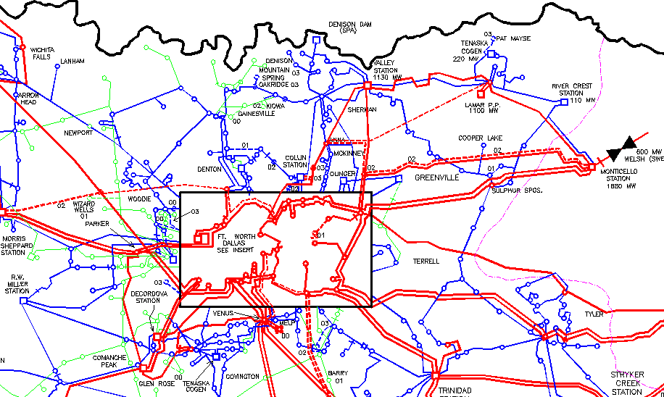
MONTICELLO-VALLEY JUNCTION-ANNA 345 KV LINE
PARIS SW-ANNA 345 KV LINE
JACKSBORO-WEST DENTON 345 KV LINE
WEST DENTON-NW CARROLLTON 345 KV SECOND CIRCUIT
CENTERVILLE SW-MCCREE SW 345 KV AND 138 KV LINES
LIMESTONE-WATERMILL 345 KV LINE
WATERMILL-CEDAR HILL 345 KV SECOND CIRCUIT
VENUS-LIGGETT 345 KV LINE
GRAHAM-JACKSBORO 345 KV LINE
ANNA-NW CARROLLTON 345 KV LINE UPGRADE
JACKSBORO-WILLOW CREEK-PARKER 345 KV UPGRADE

Figure 22 – ERCOT North Region and Transmission Projects

HOUSTON REGION DISCUSSION
The Houston Region is one of ERCOT’s two largest load centers, with a total load in 2000 of over 11,000 MW. It is also one of the prime areas for IPP and cogeneration development in Texas. Over 6,500 MW of new generation is expected to be added to the region resulting in significant transmission constraints in Houston and for transfers out of Houston.
The Tenaska Frontier and Calpine Pasadena II plants are already complete and went into commercial operation in 2000. The Reliant Energy Channelview and Calpine Baytown plants have each signed interconnection agreements and will be interconnected in 2001. Interconnection studies have been completed for several other plants, and all but one have signed interconnection agreements. All four remaining plants are expected to be interconnected by year-end of 2002. In addition, several retail customers in the Houston area are installing or have installed self-serve generation in the 50 – 200 MW range. Requests for interconnection are continuing to be submitted to ERCOT from generation in the Houston area.
Only considering those plants for which interconnection studies have been completed, transmission studies of the cumulative effect of these new plants indicate multiple transmission system loading concerns within the Houston area and for exports out of the Houston area. ERCOT identified a major east – west Houston bulk constraint and has reviewed and recommended a major 345 kV project to address this constraint. This is an upgrade of the Cedar Bayou – King – North Belt – T. H. Wharton 345 kV corridor. The upgrade project is now under construction, with completion expected before the summer peak 2002. However, given the increased level of new generation in the Houston area transmission studies have identified a number of additional transmission loading concerns.
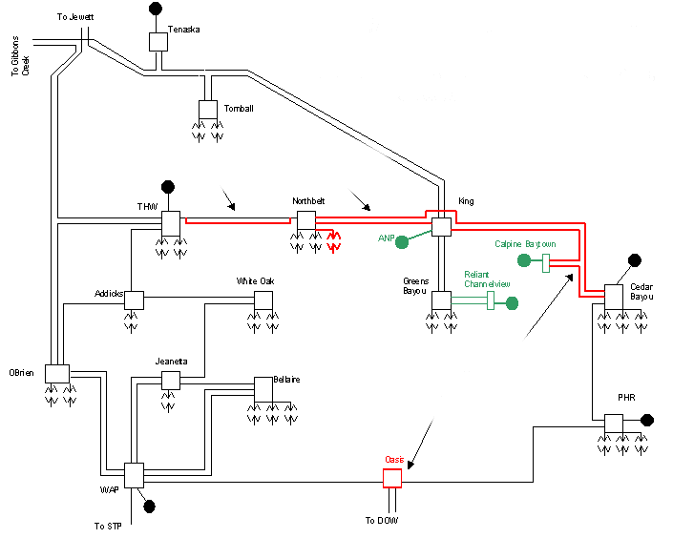

Figure 23 – Houston Area Simplified Diagram and Transmission Projects
The King – North Belt circuits, after the upgrade, will be rated for 2,390 MVA, the highest capacity circuits in the ERCOT system. Even so, these circuits will be loaded over their rated capacity under single contingency conditions unless another east to west 345 kV circuit is built and becomes operational. Moreover, additional autotransformer capacity, multiple 138 kV line upgrades, and substation upgrades will be needed. Given that the Houston region is a compact urban industrial area, rights of way are severely constrained. Therefore, upgrades generally require rebuilding existing facilities to higher capacity facilities, which takes more time than “Greenfield” construction. Upgrading existing facilities also requires extensive outages, which will be increasingly problematic as more generation is added. Moreover, multiple simultaneous outages cannot be supported without jeopardizing reliability, so construction delays are probable due to outage coordination considerations. Given these considerations, it is likely that there will be some limitations on generation output in the Houston area, beginning as early as 2001.
Beyond the local transmission infrastructure concerns, transmission studies show probable limitations on exports from the Houston area, given that the new generation capacity additions greatly exceed load increases in the area. There are four bulk, 345 kV transmission lines extending north from Houston, and all four are loaded over their rated capacity under certain single contingency conditions.
One option is to upgrade the existing lines using higher capacity conductors. The benefits of this approach would be that the cost is reasonable and no new rights of way would be required. However, the downside is that scheduling outages of the existing facilities would be difficult and would likely cause significant curtailment of energy transfers, which poses both reliability and economic risks. South to north transfers are already constrained, and the problem will be exacerbated as more generation is installed in the Houston area.
Another option is to install a new 345 kV transmission circuit from the Houston area to the north. This approach would resolve the outage scheduling problem associated with upgrading existing facilities. However, new rights of way would be required and affected landowners could oppose the project. Regardless of which option is selected, it is important that this pending constraint be addressed immediately, as the problem will grow worse over time as more generation comes on-line in the Houston area. ERCOT will oversee a regional planning process aimed at addressing this constraint.
There are other constraints that are expected to limit energy transfers out of the Houston Region as well. Specifically, studies have shown that 345 kV lines connected to the South Texas Project generating plant will be loaded over rated capacity under some scenarios. ERCOT has worked with the various transmission providers to identify ways to increase the capacity of some of the lines by upgrading substation equipment. However, additional system upgrades may be necessary.
The 138 kV transmission line between Reliant Energy HL&P’s and LCRA’s Peters substations appears to be a limiting element under base case as well as single contingency conditions. LCRA and Reliant Energy HL&P are planning another 138 kV tie line between the Hockley substation and Macedonia substation. This additional tie line will significantly reduce overloading of the Peters tie. However, additional line upgrades will still be necessary on the transmission system in the area.

Houston Region Transmission Constraint Relief Projects
To address the major constraints out of Houston Texas, the following project has been recommended by ERCOT as needed transmission facility addition and was supported by the ERCOT Board in December 1998.
LIMESTONE-WATERMILL DOUBLE CIRCUIT 345 KV LINE
Needed to maintain service to load in North Texas, increases transfer capability from Houston Region.
Individual transmission service providers in Houston Texas, have proposed the following projects. These projects have been reviewed and are recommended by ERCOT:
UPGRADE CEDAR BAYOU – KING – NORTH BELT – T. H. WHARTON 345 KV CORRIDOR
ADD OASIS SWITCH STATION
Needed to integrate IPP generation.

ERCOT, along with transmission service providers, is working to determine appropriate future actions and the following projects are being considered:

UPGRADE NORTH 345 KV LINES
Possibly needed to increase transfer capability out of Houston Region.

ZENITH-SALEM 345 KV LINE
Possibly needed to increase transfer capability out of Houston Region.

ZENITH-GIBBONS CREEK 345 kV LINE
Possibly needed to increase transfer capability out of Houston Region.

RELIANT ENERGY HLP-ENTERGY DC TIE
Since Houston is on the edge of the ERCOT system this is a possible option to increase transfer capability out
of Houston.

UPGRADE SOUTH TEXAS PROJECT 345 KV LINES
Needed to increase transfer capability to and from Houston. Several options are possible.

345/138 KV AUTOTRANSFORMER ADDITIONS
Needed to maintain service to load.

UPGRADE 138 KV AND 69 KV SYSTEMS
Needed to maintain service to load.

ADD REACTIVE COMPENSATION (VOLTAGE SUPPORT CAPACITORS)
Needed to provide voltage control and maintain service to load.

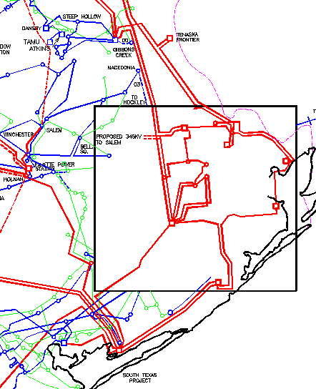
CEDAR BAYOU-KING 345 KV UPGRADE
KING-NBELT-THWHARTON 345 KV UPGRADE
SOUTH TEXAS PROJECT 345 KV UPGRADES
GIBBONS CREEK 345 KV
SALEM 345 KV
ZENITH 345 KV

Figure 24 – ERCOT Houston Region and Transmission Projects

WEST REGION DISCUSSION
Significant changes have occurred on the West Texas system, including new generation additions. Up to 1,000 MW of new IPP generation is expected to come on line in 2001. In addition, ERCOT has received over 20 requests for new generation interconnection in West Texas accounting to more than 2,000 MW. Most of these requests are for renewable energy (wind) resources to support the renewable energy mandate of Senate Bill 7.
West Texas generation capacity currently exceeds peak load by over 600 MW. Exports from West Texas are limited by post-contingency thermal loading limits of several 345 kV and 138 kV lines. The addition of a new IPP project and renewable generation will exacerbate the existing limitation. Light load in West Texas will also aggravate this constraint. Imports to West Texas are limited by a post-contingency stability limit that will result in an unstable system condition that could result in separation and/or loss of the generation in West Texas. This condition occurs when load exceeds generation in West Texas and is still likely to occur when generation is forced out or is off line for maintenance.
Studies have been completed to determine the extent of transmission improvements necessary to support the current wind powered generation interconnection requests in Pecos County. Along with upgrading of existing 138 kV and 69 kV transmission lines, two new 138 kV lines were also determined to be necessary for the export of power out of the Pecos County area.
There are two paths for power to flow from the wind generation to the bulk transmission system from the Pecos County area. One path extends north through Crane to Odessa, and the other extends east through Big Lake and Ozona to San Angelo. The 345 kV point of termination of these paths are the Odessa EHV Station and the proposed Twin Buttes Station, respectively. The northern 345 kV transmission line corridor in West Texas carries the majority of power out of West Texas.
Renewable generation is also being added to the Davis Mountains area of West Texas. Along with upgrading of existing 138 kV and 69 kV transmission lines, additional new 138 kV lines are necessary for the export of power out of the Davis Mountains area.
Service to load in the Brownwood, Comanche and Dublin area is provided via the Seldon to Dublin 138 kV line and the Comanche Peak-Comanche Switch 345 kV radial line. A contingency outage of either of these lines during a maintenance outage of the other line will result in a loss of service to this area.
To provide for transfers to and from West Texas, maintain service to load and integrate new generation resources into ERCOT, transmission additions are required.

West Region Transmission Constraint Relief Projects
To address the major constraints to and from West Texas, the following projects are recommended by ERCOT as needed transmission facility additions and were supported by the ERCOT Board in December 1998.
MORGAN CREEK-TWIN BUTTES-RED CREEK-COMANCHE SWITCH 345 KV LINE
Needed to increase transfer capability to and from West Region and integrate new generation. Will also help
to provide service to load in North Region. Needed to maintain service to load in San Angelo and
Brownwood-Comanche area
GRAHAM-JACKSBORO 345 KV LINE
Needed to increase transfer capability to and from West Region and integrate new generation. Will also help
to provide service to load in North Region.

Individual transmission service providers in West Texas have proposed the following project. This project has been reviewed and is recommended by ERCOT:
KUNITZ-WINK 138 KV LINE
Needed to integrate new renewable generation being developed in Davis Mountains.
ERCOT, along with transmission service providers, is working to determine appropriate future actions and the following projects are being considered:
WINK-MIDLAND EAST 138 KV LINE
Possibly needed to integrate new renewable generation.

JACKSBORO-WEST DENTON 345 KV LINE
Needed to maintain service to load in North Region, integrate IPP generation and integrate renewable energy
generation.

RED CREEK-COMANCHE SW 345 KV SECOND CIRCUIT
Possibly needed to integrate renewable generation.

COMANCHE SW-KILLEEN SW 345 KV LINE
Possibly needed to integrate renewable generation and maintain service to load in Killeen.

RIO PECOS 138 KV STATCOM (VOLTAGE CONTROL)
Needed to maintain voltage control in Pecos County with addition of renewable generation.

345/138 KV AUTOTRANSFORMER ADDITIONS
Needed to maintain service to load.

UPGRADE 138 KV AND 69 KV SYSTEMS
Needed to maintain service to load.

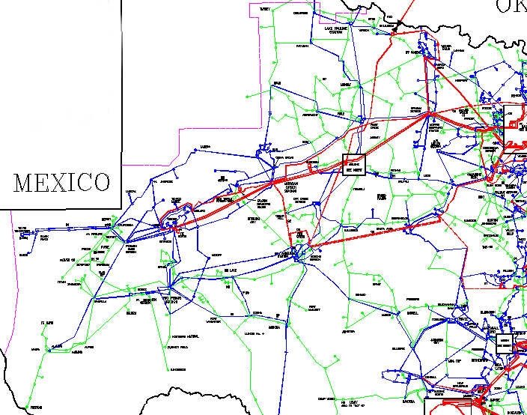
KUNITZ-WINK 138 KV LINE
RIO PECOS AREA 138 KV UPGRADES
MORGAN CREEK-TWIN BUTTES-RED CREEK 345 KV LINE
RED CREEK-COMANCHE SW 345 KV LINE
COMANCHE SW-KILLEEN SW 345 KV LINE
WINK-MIDLAND EAST 138 KV LINE
GRAHAM-JACKSBORO 345 KV LINE
JACKSBORO-WEST DENTON 345 KV LINE

Figure 25 – ERCOT West Region and Transmission Projects

CENTRAL REGION DISCUSSION
Significant changes have occurred on the Central Texas system, including new generation additions. Up to 4,000 MW of new IPP generation is currently under construction. ERCOT has received requests for even more generation interconnection in Central Texas. Significant load growth is also occurring in Williamson and Travis counties.
Addition of the Lost Pines Generating Plant results in post-contingency thermal loading on the Holman to Lytton 345 kV line during the outage of the Lost Pines to Austrop 345 kV line. Review of available transfer capability (ATC) calculations indicates that the Fayette to Austrop 345 kV and the Holman to Lytton 345 kV circuits are among the top limiting elements for most transfers from South Texas to Central Texas and North Texas.
Studies of the Bryan/College Station area with continuing load growth indicate possible voltage problems when generation is out of service in the area. Recent operation experience in the area indicates a need for additional facilities sooner than expected. Installation of a 345/138 kV autotransformer and 138 kV lines into the area will help to support continued service to load.
In order to support energy transfers from Central Texas, fully integrate IPP and provide for future service to the Bryan/College Station, area additional transmission is needed.

Central Region Transmission Constraint Relief Projects
Individual transmission service providers in Central Texas have proposed the following project. This project has been reviewed and is recommended by ERCOT:
FAYETTE-AUSTROP AND HOLMAN-LYTTON 345 KV LINES
Needed to integrate new IPP generation and increase transfer capability.
ERCOT, along with transmission service providers, is working to determine appropriate future actions and the following projects are being considered:
SALEM-BRYAN/COLLEGE STATION-TNP ONE 345 KV LINE
Needed to maintain service to load in Bryan/College Station area and increase transfer capability out of
Central Region.

ESTABLISH WILLIAMSON COUNTY 345 KV SWITCHING STATION AND 138 KV ADDITIONS
Needed to maintain service to load in Williamson County.

UPGRADE 138 KV AND 69 KV SYSTEMS
Needed to maintain service to load.

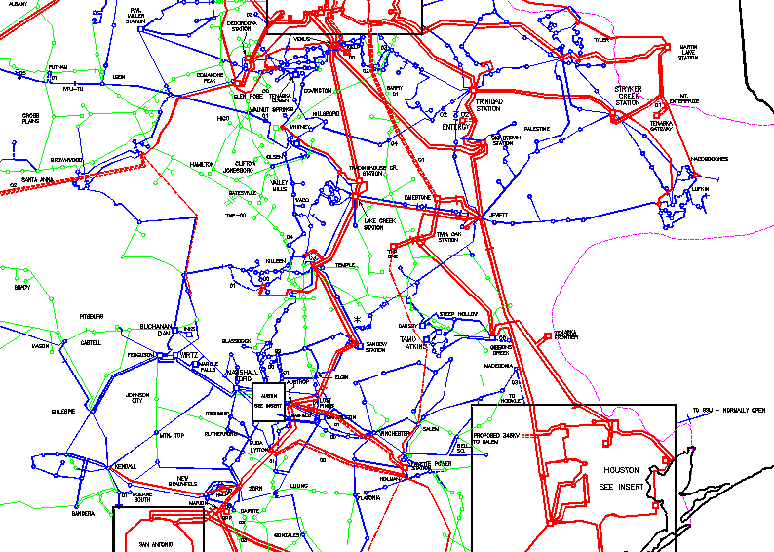
FAYETTE-AUSTROP 345 KV LINE
HOLMAN-LYTTON 345 KV LINE
SALEM-BRYAN/CS-TNP ONE 345 KV LINE
WILIIAMSON COUNTY 345 KV SWITCH STATION

Figure 26 – ERCOT Central Region and Transmission Projects

DISTRIBUTION CONSTRAINTS
Constraints that impact the ability for consumers to change retail service providers are of interest. ERCOT can identify the transmission constraints, but ERCOT is dependent on the distribution service providers for input on distribution constraints. Distribution constraints do not affect the ability of specific generation to serve load, but whether or not the load can be served. The configuration of a distribution system (i.e., predominately a radial system) is such that there are no constraints that are comparable to those on a transmission system. In order to comply with the distribution portion of this report ERCOT requested the assistance of the distribution service providers, load serving entities, electric power cooperatives and municipal utilities. Those parties identified no current distribution constraints that would affect their ability to accommodate switching by customers among different retail service providers.
Distribution entities usually monitor and perform a comprehensive analysis of their distribution system during peak load periods. During this analysis of the distribution system, the following areas are analyzed: substation transformer and breaker loading, conductor and line device loading, load balance, steady state voltage level, short circuit protection and coordination, service reliability, and system configuration. This analysis is the basis for distribution system improvements that are performed to ensure the continued safe and reliable provision of electric service to customers.
Constraints on the distribution system may become a concern because of distributed generation additions being made to the distribution system.

